**Lex Notes (2)**

* **Git/Github/Gitlab**
* Git is tool for local computer, use git command, like Clearcase, RTC
* Github/Gitlab are hosting in cloud server for SaaS purpose.
* **WinSCP:** similar like FTP file copy
* **Putty:** using Linux/IBM AIX command to access server in UNIX
* **AIX:** using Linux/IBM AIX command to access server in UNIX
* **Ajax Call**
* **JSF Component**
* **HTML5**
* Base: <DOCTYPE html>, head, title, matedata, footer, body
* Elements: div, list, <br/>, <a> link,
* Table: <table>, <tr>, <dt>
* Form: <form> <input>, button, submit, …
* Hidden: image, audilt, video, ifrom.
* **CSS (Cascading Style Sheets)**
* Cascading style sheets are used to style our webpages. This course helps you to learn how to style our webpages, different ways of styling, usage of selectors and style properties, debugging CSS. Developers choose CSS to describe how HTML elements are to be displayed on the browser. CSS helps in controlling the layout of multiple web pages at once. CSS helps in providing appealing look and feel to the web pages and also loads the web pages quickly.

**HTML** structures collection of information and **CSS** provides the presentation for how to display those document content in page.

**Instead of using HTML tag property to display content, we’re better to use CSS styling rules and attributes to format it, such as color, image, location, … etc.**

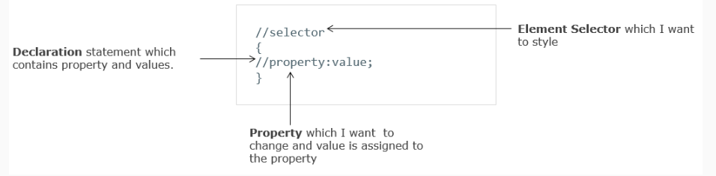

* Where to write style rules
  + - Inline Styling: html element uses style attribute to style content

<h1 style=”color:#607d8b;text-align:center”>Hello</h>

* + - Internal Styling:

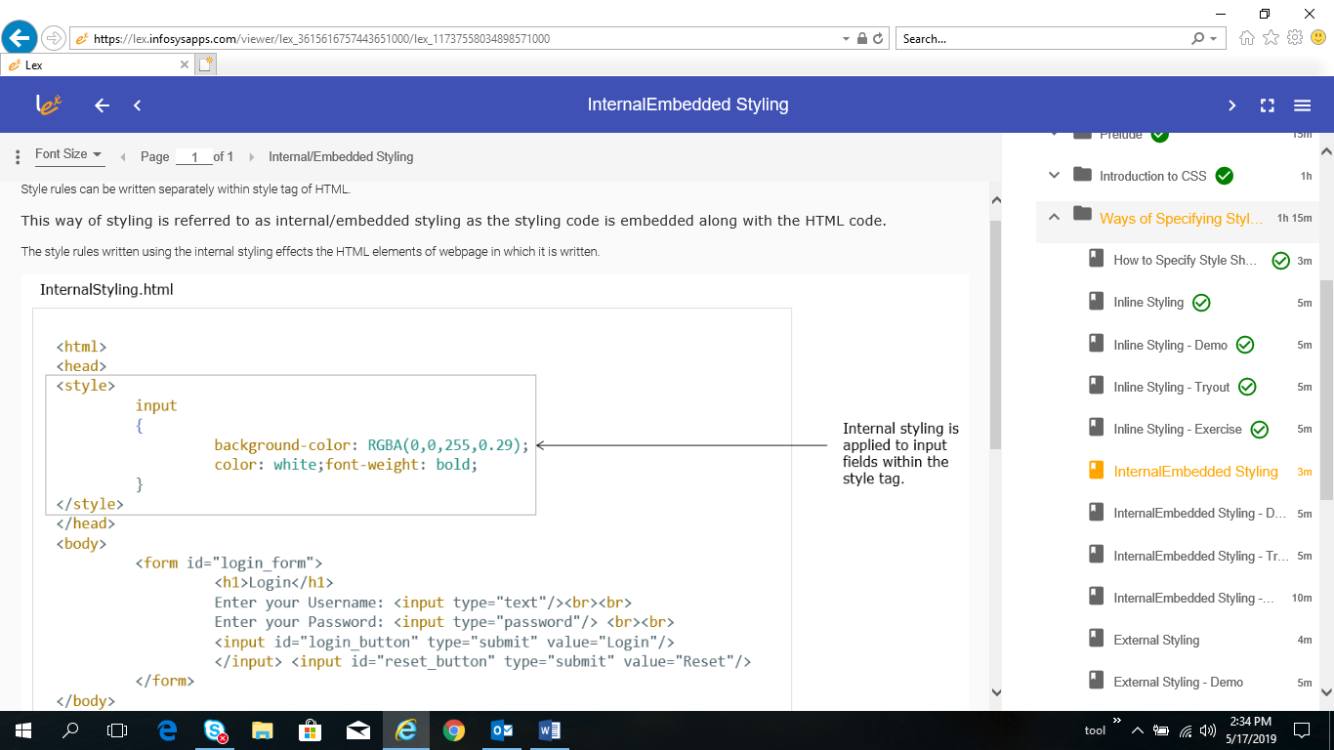

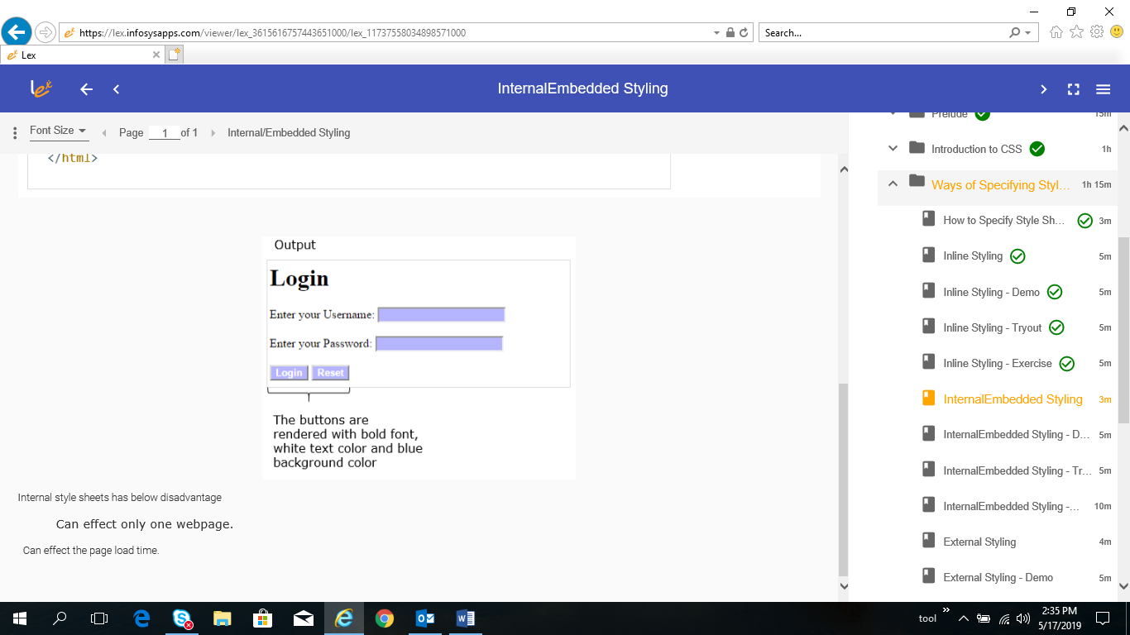

* + - External styling

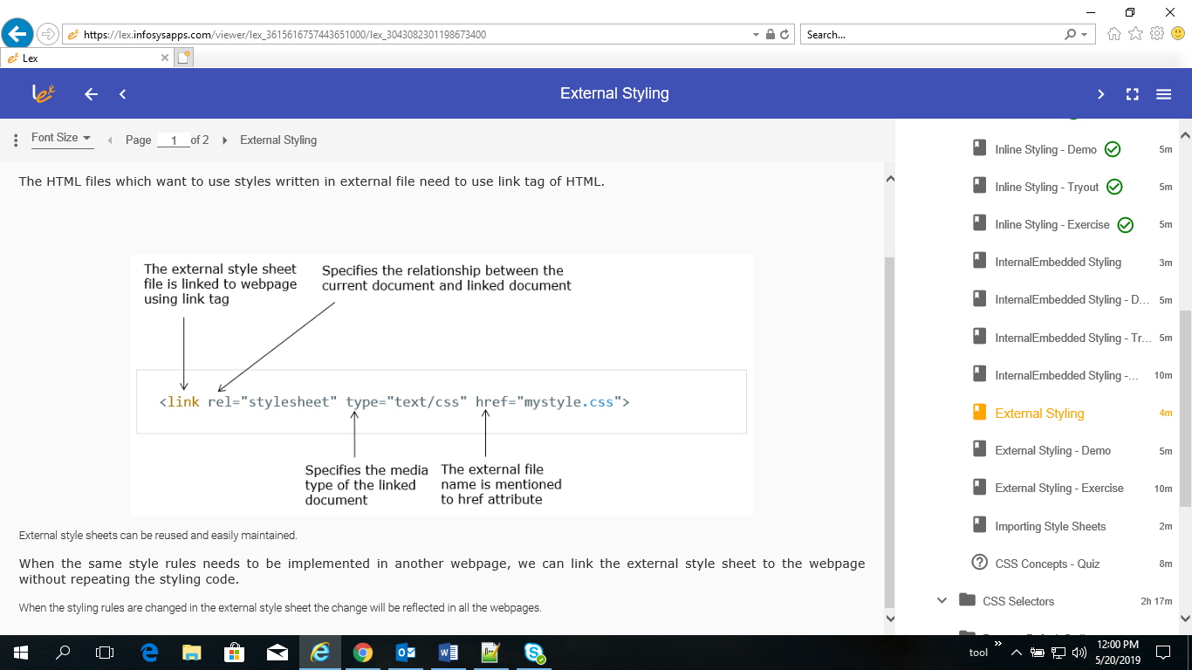

* + - Import styling sheet

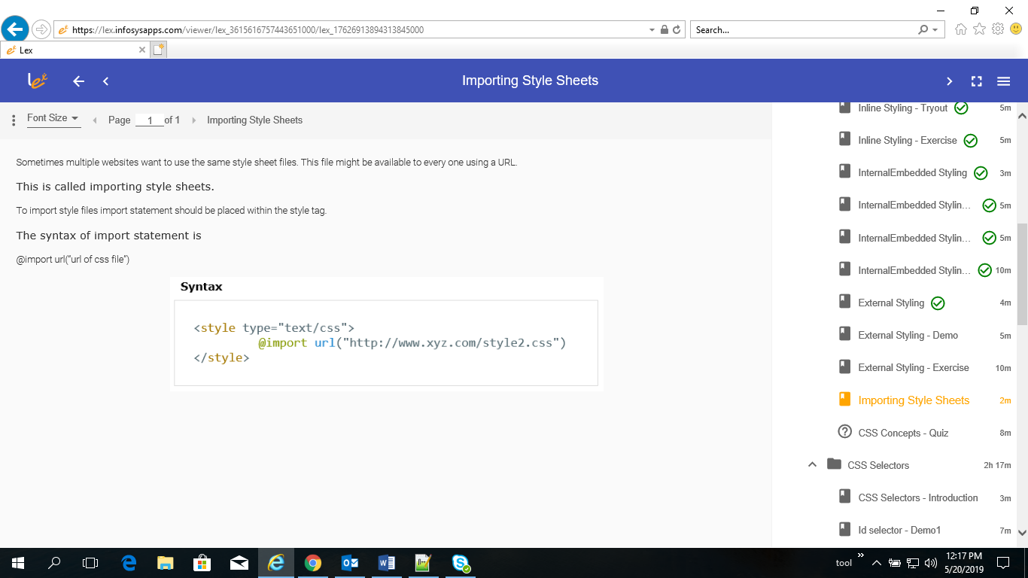

* Selector
  + - element selector

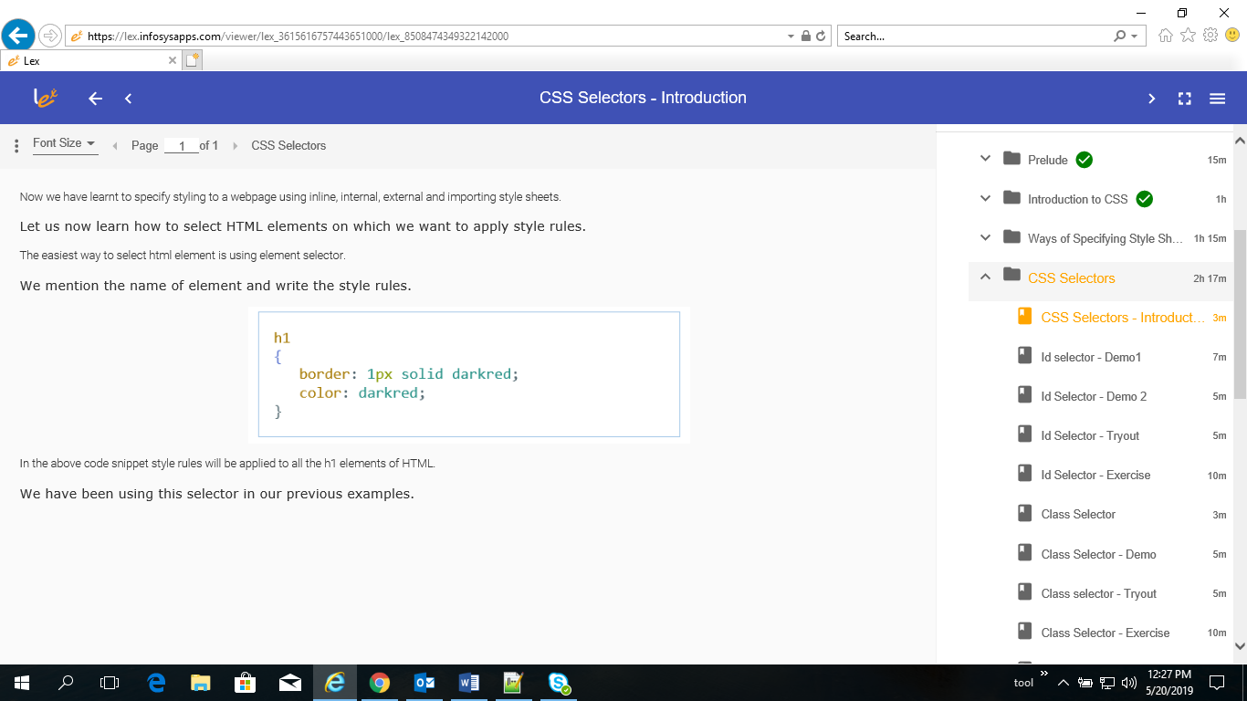

* + - id selector

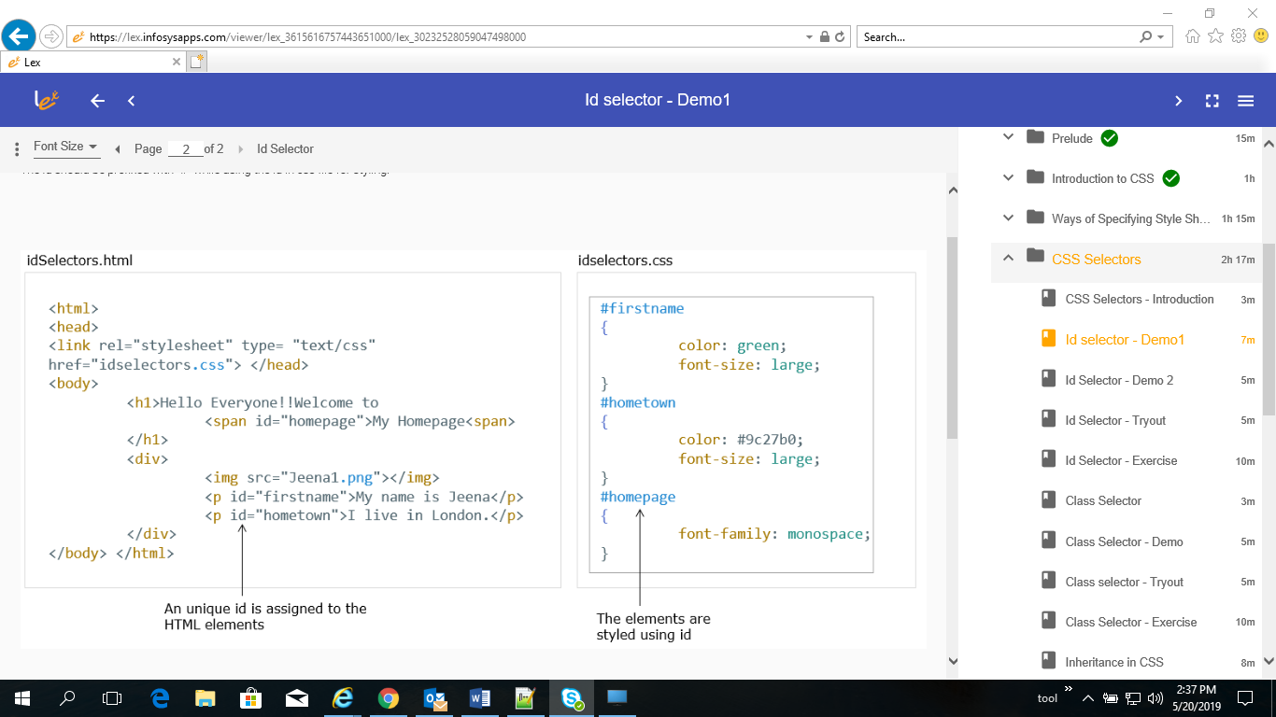

* + - class selector

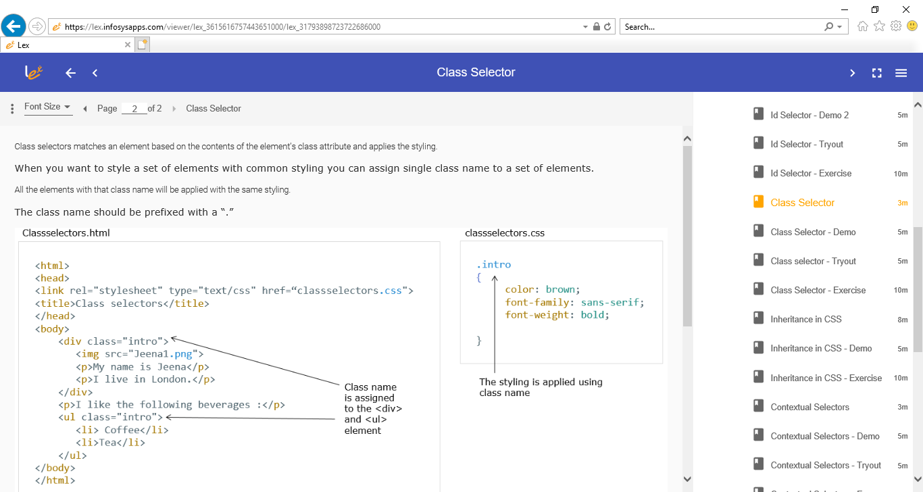

* + - Inheritance: you don’t need style all element individually, only style body element. Child elements can inherit the style of parent element (some is not always inherited by child).
    - Context selectors
    - Grouping of Selectors: If you want to apply same style to different elements, use group option to use style code only once.

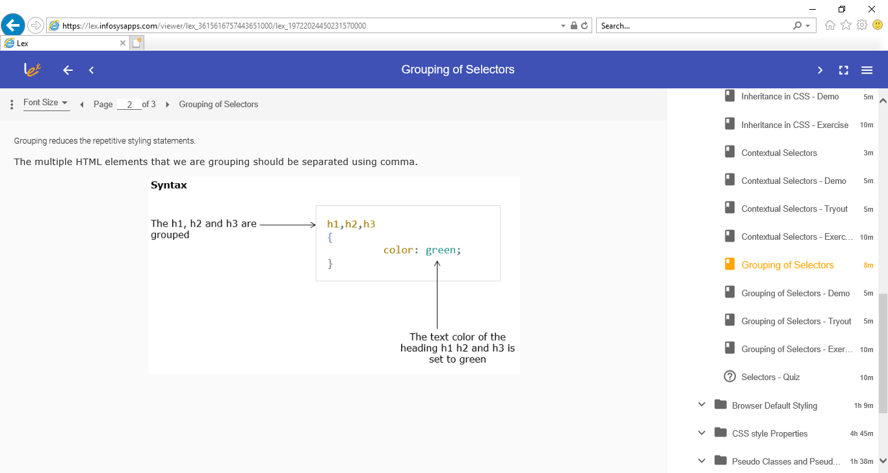

* Browser Default Styling
  + - You might have observed in websites the links are rendered with underline and blue in color even without any styling being specified by the developer. Browser adds some minimal styling to the web page. The browser styling will be overwritten when developer includes styling to the webpage

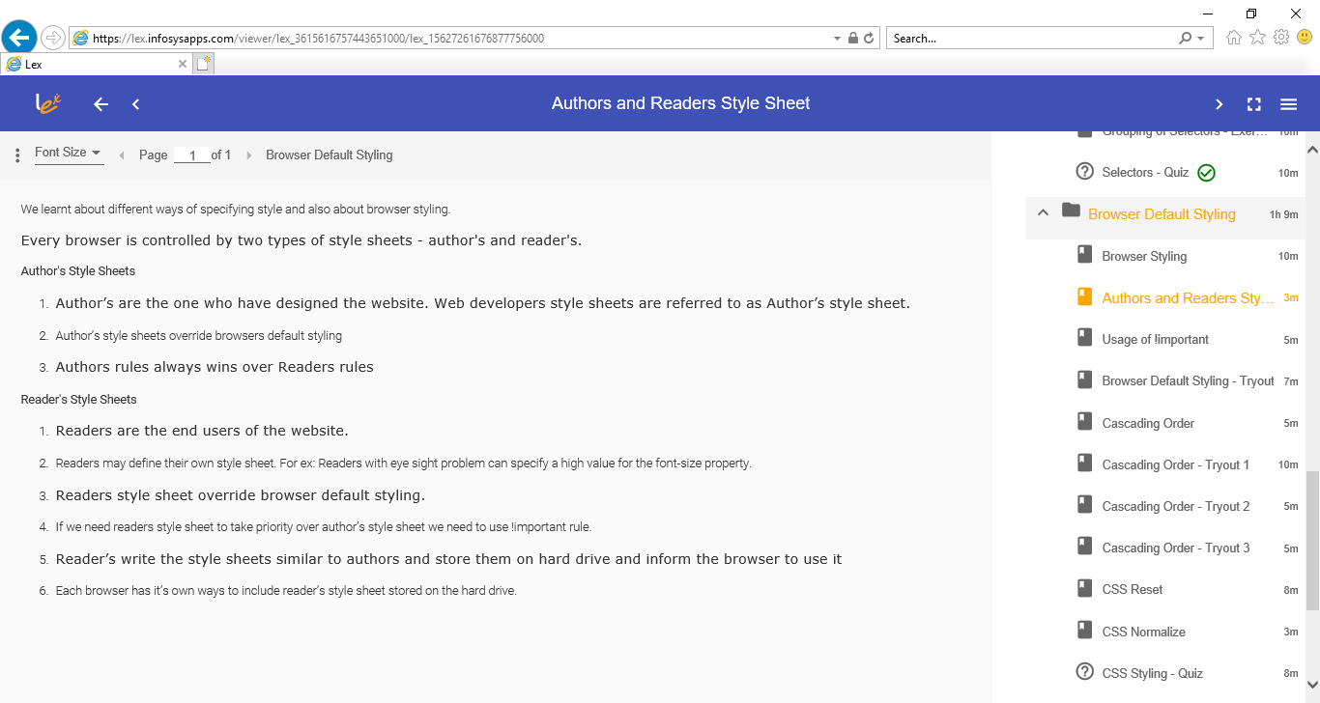

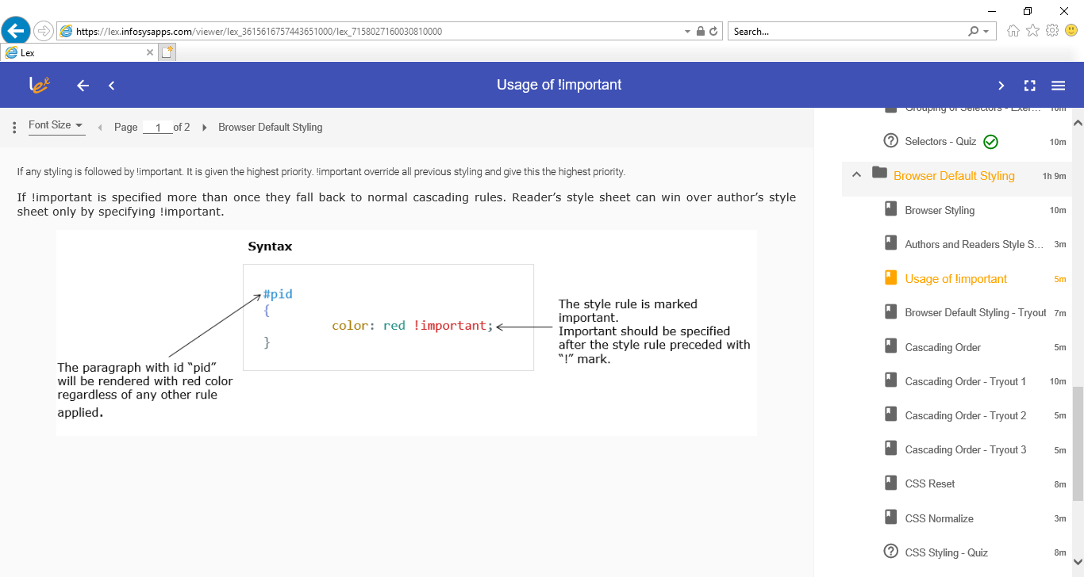

* + - Cascading Order
* CSS style Properties
  + - Background property: scroll, repeat-x….
    - Colors: name, hexadecimal code or RGB
    - Font

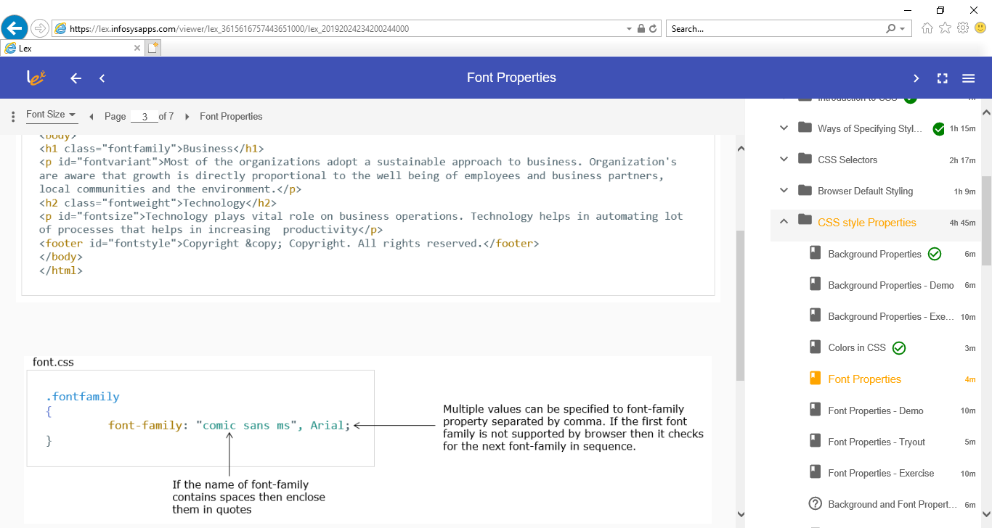

* + - Text properties

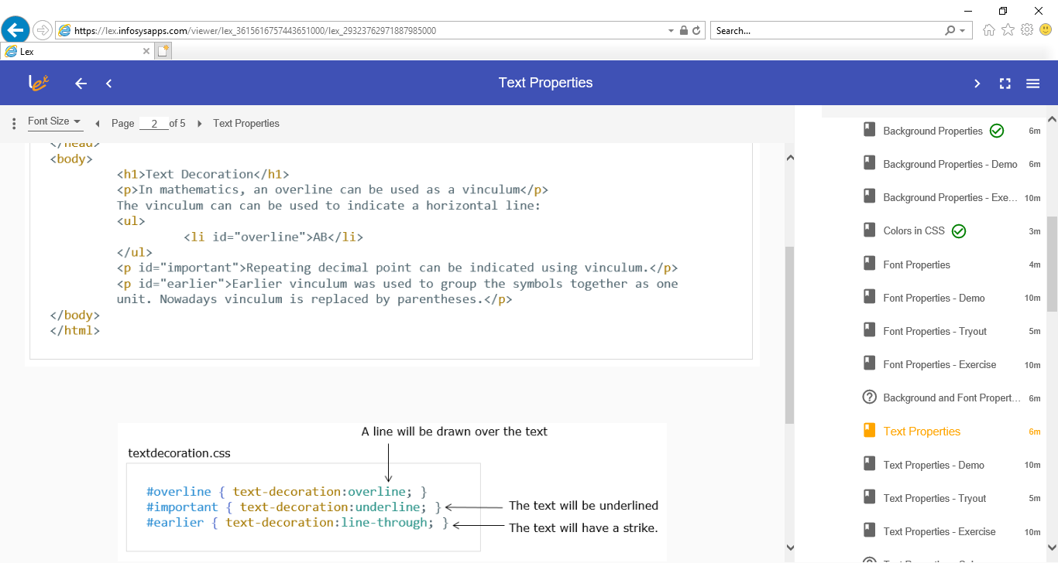

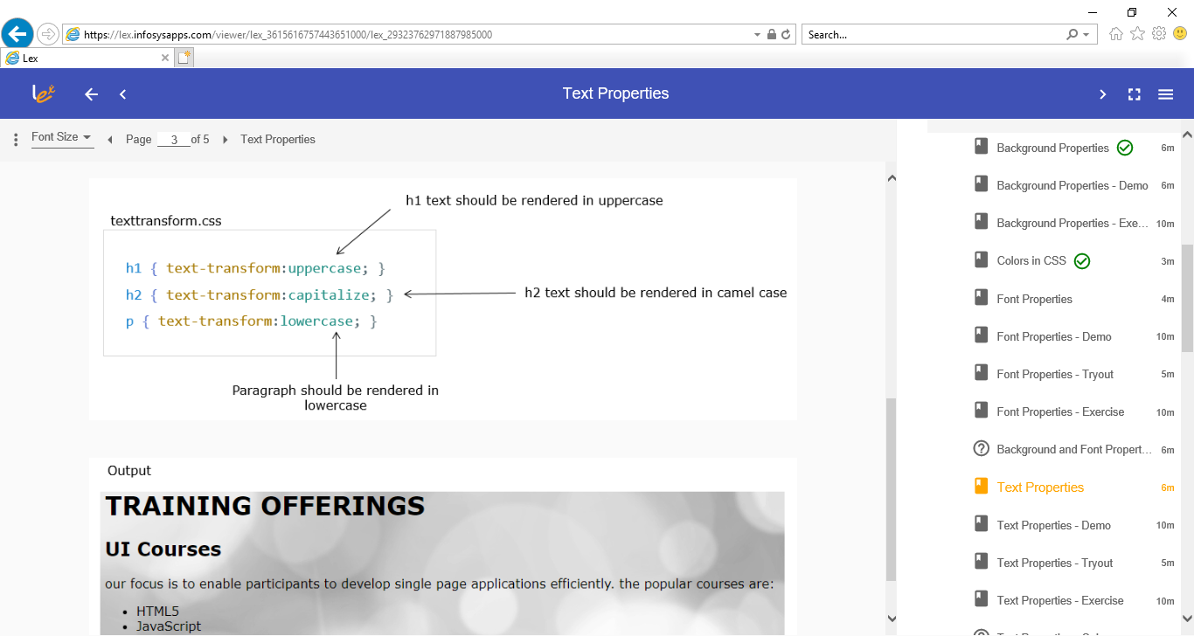

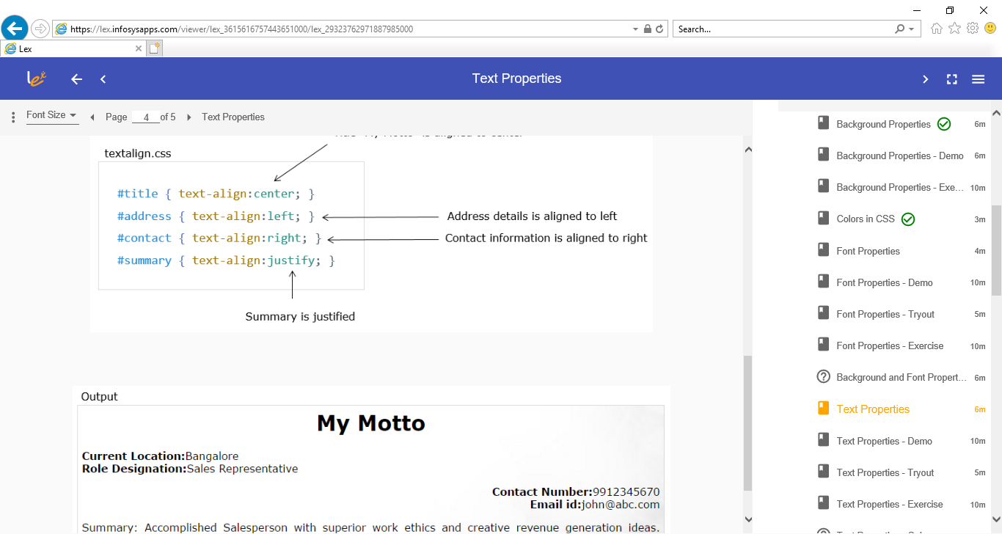

* + - Margin
    - Padding
    - Border
    - Classification
    - Position
    - Z-index
* Psedudo Class and element
* Debugging CSS

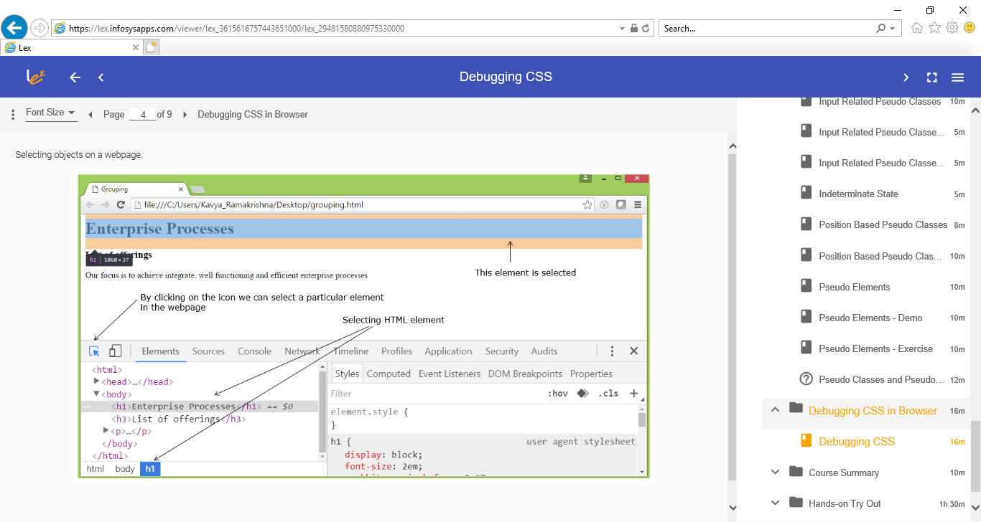

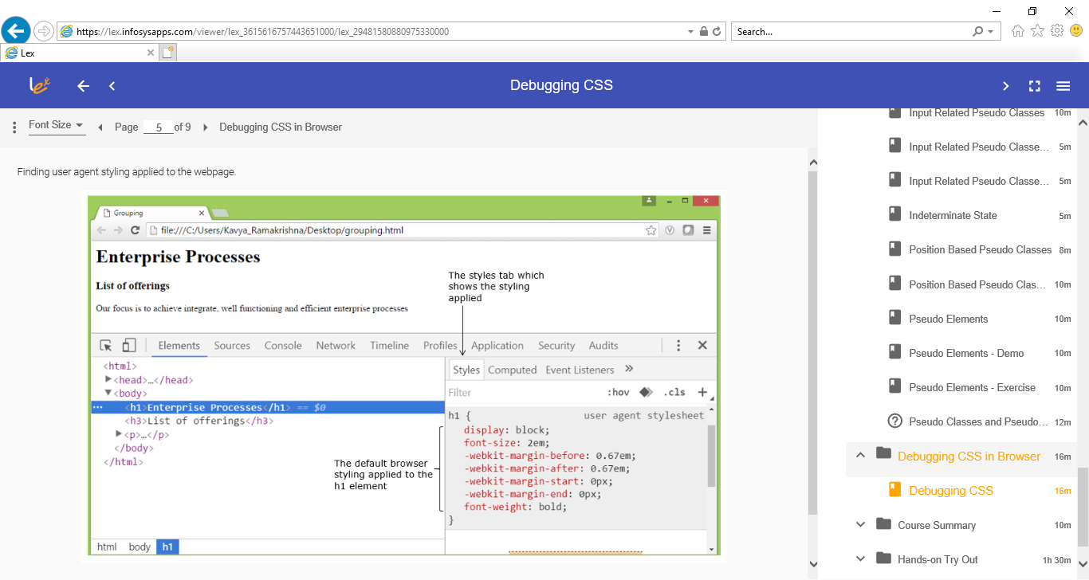

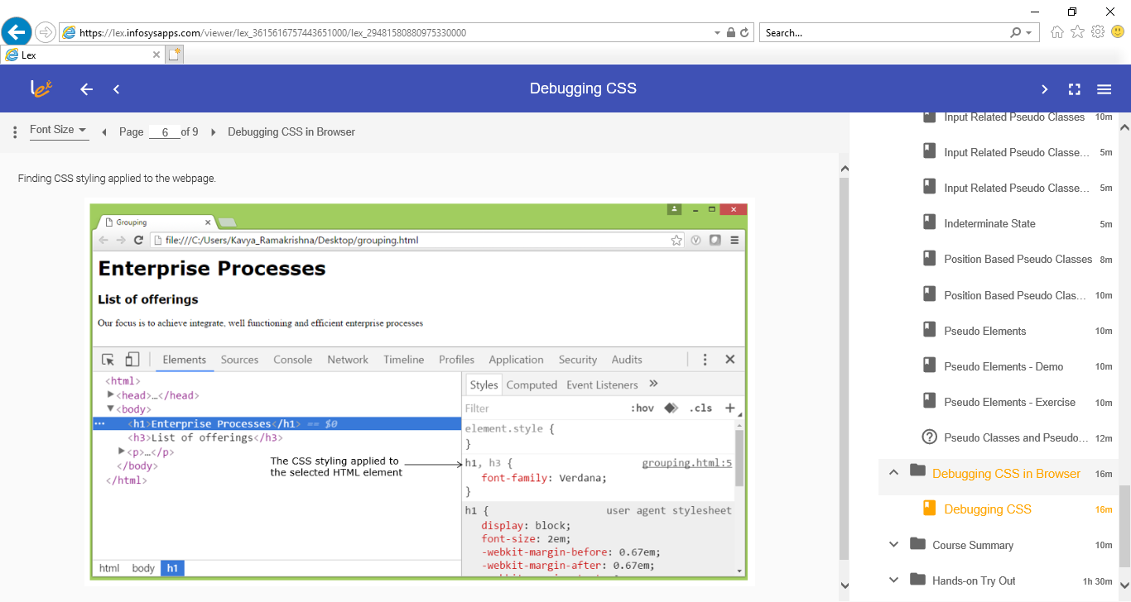

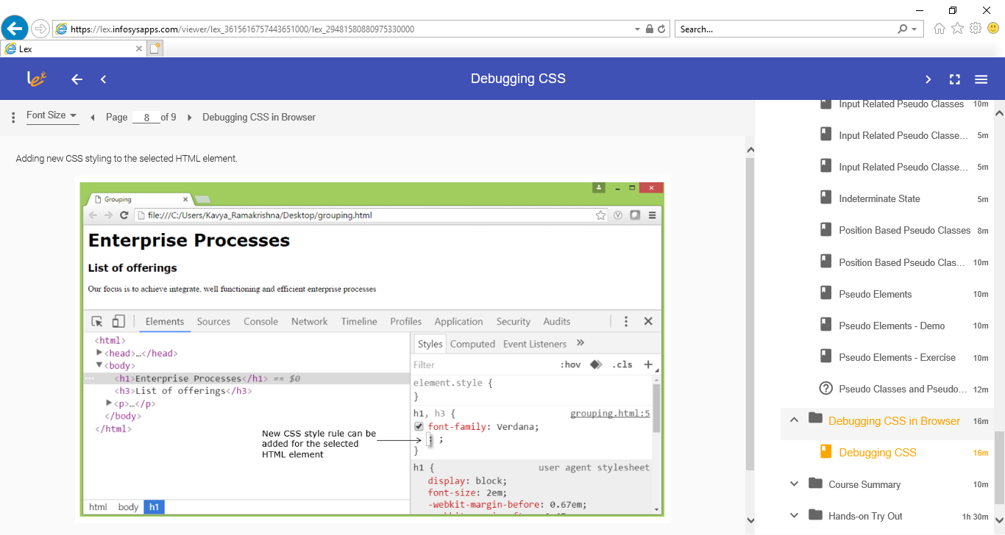

* **JavaScript (originally Live Script)**
* Web page designed using HTML and CSS is static and JavaScript combined with HTML and CSS makes it dynamic.
  + - Create dynamic, interactive and scalable web applications
    - Core language in front with page embedded
    - Browser has engine to execute JavaScript code
    - JavaScript has all: variable define, object, type, operation, loop, function and call, predefined lib object and function
* Base
  + - Internal: put in head or body <script type=”text/javascript” src=”name.js”></script>
    - External file: name.js is not written inside <script></script>
    - JavaScript is type-looser or dynamic type. Same name could have different type depends on init type.
    - var companyName = "Infosys's"; **OR** var companyName = 'Infosys"s'
    - var companyName = "Infosys"s"; **OR** var companyName = 'Infosys's' is syntax error.
    - when you have to write string within a string, use different quotes for both
    - var, type, operator, statement, loop (for, while, do_while, break, continue, if-else switch condition, function, var scope.
    - function: don’t have return type (null if no return), don’t have parameter type.
    - Var scope: global, local and nested. Variable without keyword var will be in global even inside function.
* Events handle
  + - when the interaction happens, the event triggers. JavaScript event handlers enable browser to handle them. JavaScript event handlers invoke the JavaScript code to be executed as reaction to the event triggered. when execution of JavaScript code is delayed or deferred till some event occurs, the execution is called as deferred mode execution. This makes JavaScript an action-oriented language. submit, click, URL change/navigation, hid content, trigger.

|  |  |  |
| --- | --- | --- |
| **Event** | **Event-handler** | **Description** |
| click | onclick | When user clicks on element, event handler onclick handles it. |
| keypress | onkeypress | When user presses keyboard's key, event handler onkeypress handles it. |
| keyup | onkeyup | When user releases keyboard's key, event handler onkeyup handles it. |
| load | onload | When html document is loaded in browser, event handler onload handles it |
| blur | onblur | When element loses focus, event handler onblur handles it. |
| change | onchange | When selection of checked state change for input, select or text-area element changes, event handler onchange handles it. |

* + - Event handlers are associated with HTML elements and are responsible to handle or listen to the event taking place <p onclick=”executeMe()”>excuteMe</p>
    - Inline Scripting where we embed lines of JavaScript code inline to HTML elements. <p onclick=’alert(“this has been click”)>This</p>
* Object
  + - Type: created object, global object, object talking with browser and HTML – BOM and DOM (Browser object module and HTML document object module) – HTML/JavaScript/Browser need to talk one another.
    - Create object: using literal notion and function constructor(new).
    - Global object:
      * string, length
      * Date, .getMonth, …
      * RegExp, test()
      * Array (similar collection not array), can be different type for item, push, pop, forEach, slice, concat.
      * Math, math.PI, math.SQRT9, math.MIN(), math.floor()
      * JSON object (JSON data) passed over network, {“key”:”value”}
    - Javascript object: {firstname: “Sam”, lastname:”Fernades”} key is not in double quotes.
    - JSON object: {“firstname”: “Sam”, “lastname”: “Fernades”} both key/value in double quotes.
    - Method: JSON object/JSON data = JSON.parse(string),
    - String = JSON.stringify(JSON object/JSON data)
    - var JSONData = {
    - "customer" : [
    - {"firstName":"Bob", "lastName":"Morry"},
    - {"firstName":"Kate", "lastName":"Ward"}
    - ]};
    - var JSONString = '{"firstName": "Bob", "lastName": "Morry"}';
    - var user = JSON.parse(JSONString);
    - document.write('First Name: ' + user.firstName + '<br><br>' );
    - document.write('JSON data is: ' + JSONData.customer[1].lastName);
* BOM
  + - Bowser Object Module: javascript control content of HTML displayed through BOM. Root object is window: History, Navigation, Location and Document.
    - BOM object - document
* DOM is W3C provide API, tree, node/element, properity and method to access each element in HTML.
* DOM method: ***getElementByXX()*** to get content(object, text, list) of element:

document.getElementById()

document.write(‘…’);

* DOM object document properties: ***document.***(head, body, form and images) return those element in html page.
* DOM object element properties : get/set content of element
* innerHTML: document.getElementById(“div1’).innerHTML
* attribute: document.getEmenetById(“div1”).setAttribute(‘class’,’div2’);
* style: <div id=”div1”>

<h1 id=….>….</h1>

<p id=”para1” style=”color:blue”>Let.</p>

</div>

<script>

document.getElementById(“div1”).style.color=’red’;

</script>

* + - BOM object – window
    - Window properties: innerHight/innerWith/sessionStorage/localStorage
    - Window method:
* window.open(“http:google.com”);
* window.close();
* wondow.alert(), prompt(), confirm()…
  + - BOM object – history
* history.length()
* history.back() – loads previous URL from history list
* history.forward()
* history.go()
  + - BOM object – location
* DOM
  + Html document as node, each element as node and text between elements as text node. This hierarchical structure inside the browser is called DOM tree.
    - Root, parents, sibilings.
    - Methods to add and remove an element in html page:

document.createElement()

document.createTextNode()

document.getElementById(“div1”).appendChild(newTextElement)

document.get….removeChild(document.get…)

* + Using DOM to handle javascript events
    - Handle events with inlinescrip, tired script code and element together

<p onclick=”create()”>click</p> or

<p onclick=function(){alert(‘…’)};>…</p>

* + - Handle events with DOM API

HTML: <p id=”para1”>Para1</p>

<p id=”para2”>Para2</p>

1. Using event handler

document.getElementById(‘para1’).onclick=function(){alert(‘para1’};

1. Using event listener

Document.getElementById(“para2’).addEventListener(‘click’,

Function(){alert(’para2’);}, false);

We don’t need change html, just add some scripts using DOM API

* + - Events in JavaScript are considered as objects.

When Events are fired, the 'event' object is generated by the

browser. This object encapsulates all data related to that event.

To access or manipulate this object, we can optionally pass it as first

argument to the event handler function

Object property

1. Target: event.target – refers elemenmt
2. Type: even.type – refers click, load etc
3. Method: event.preventDefault(): cancel default
   * 1. Action and add user-defined action.

* **JQuery**
  + What is JQuery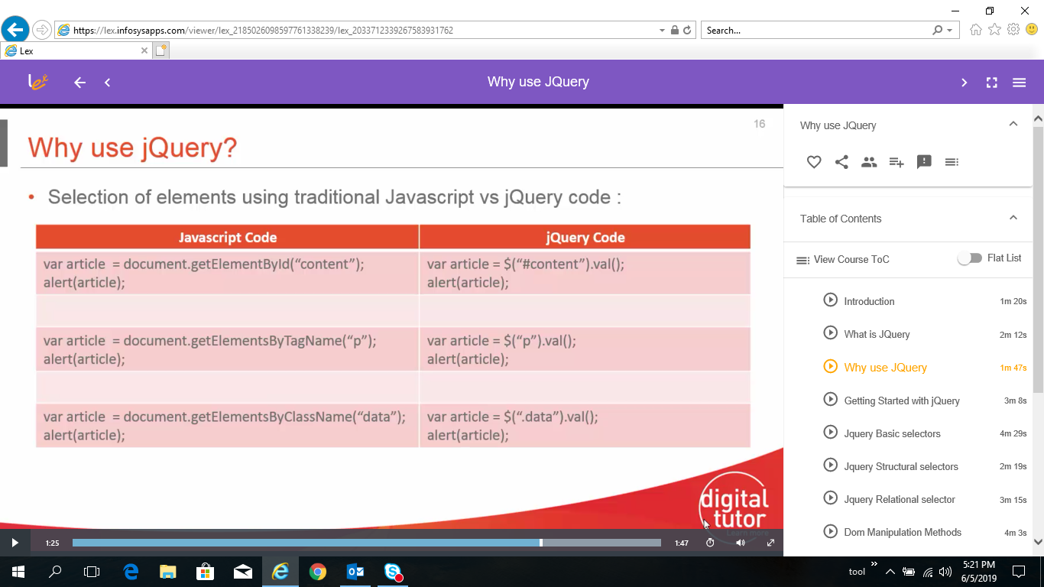
  + JQuery Download

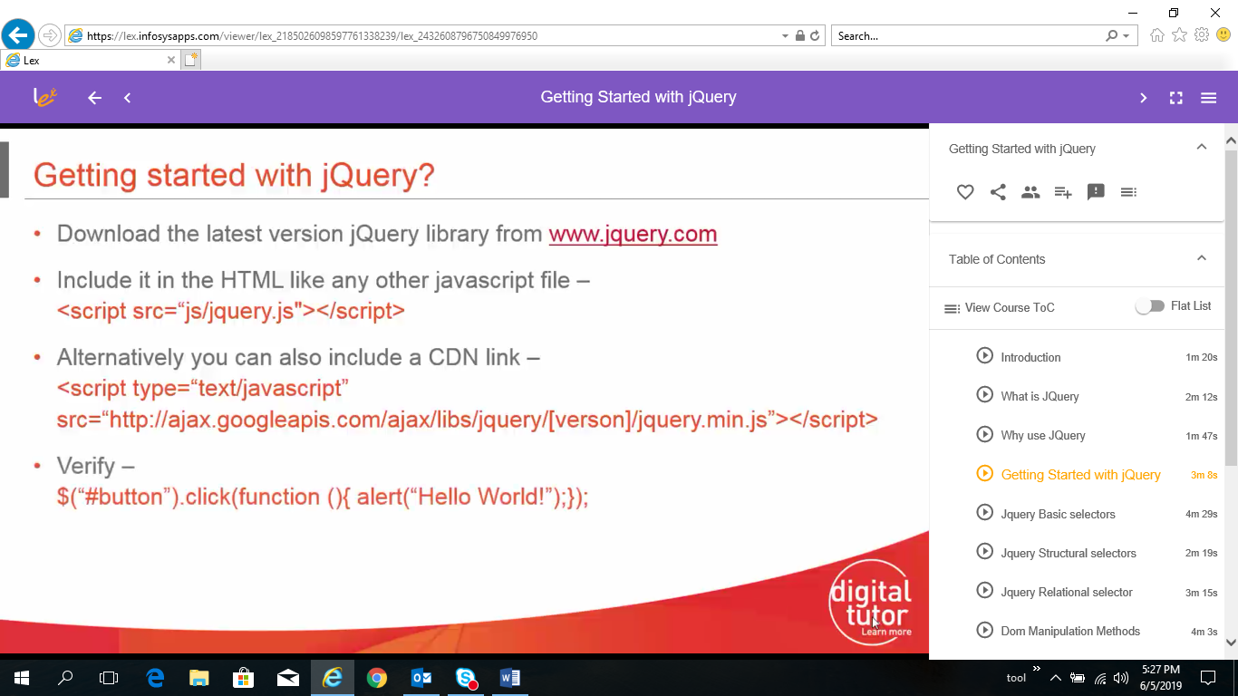

* + JQuery Selector Base

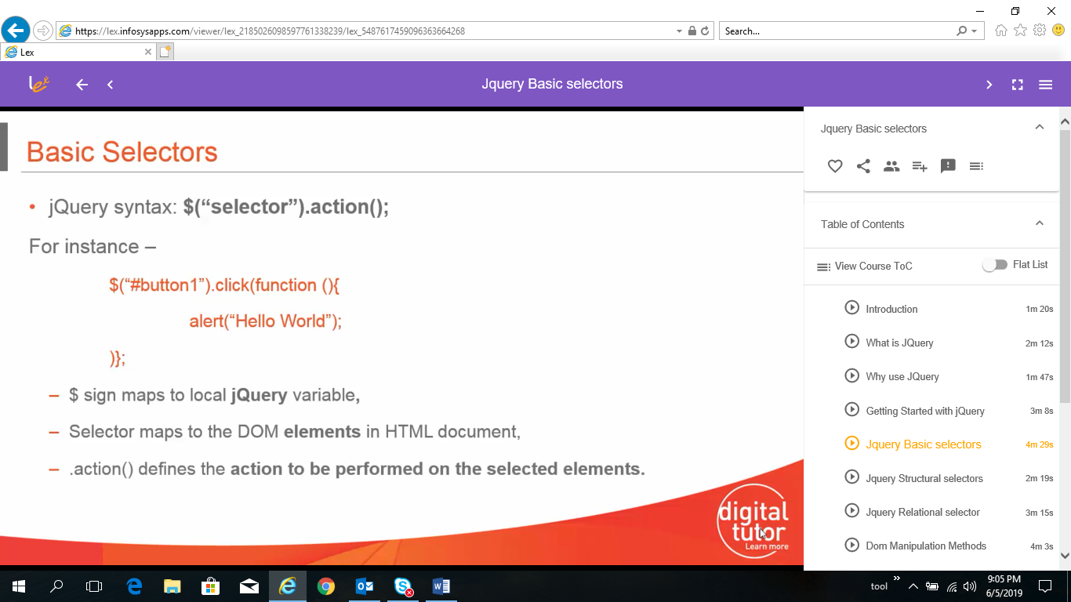

* + JQuery Structure Selectors

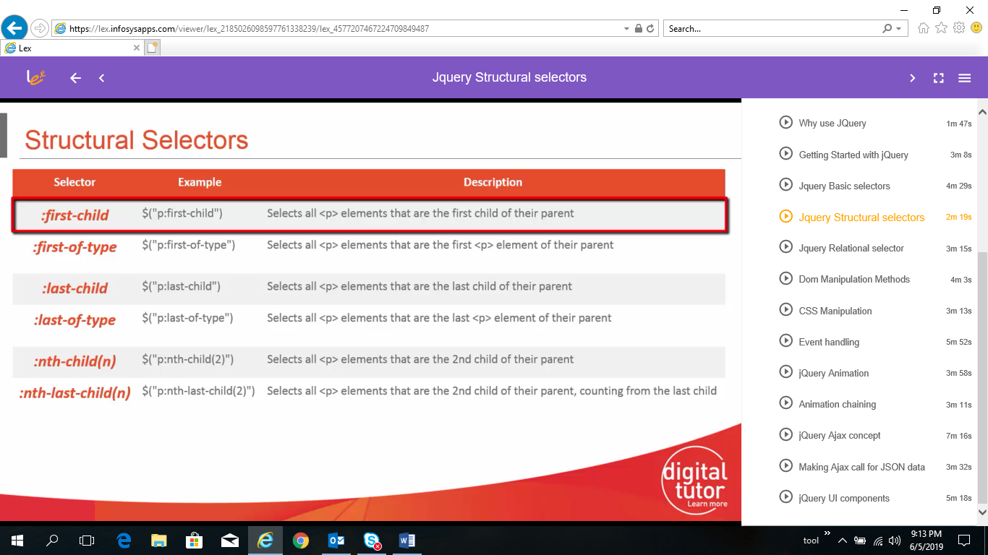

* + JQuery Relation Selectors

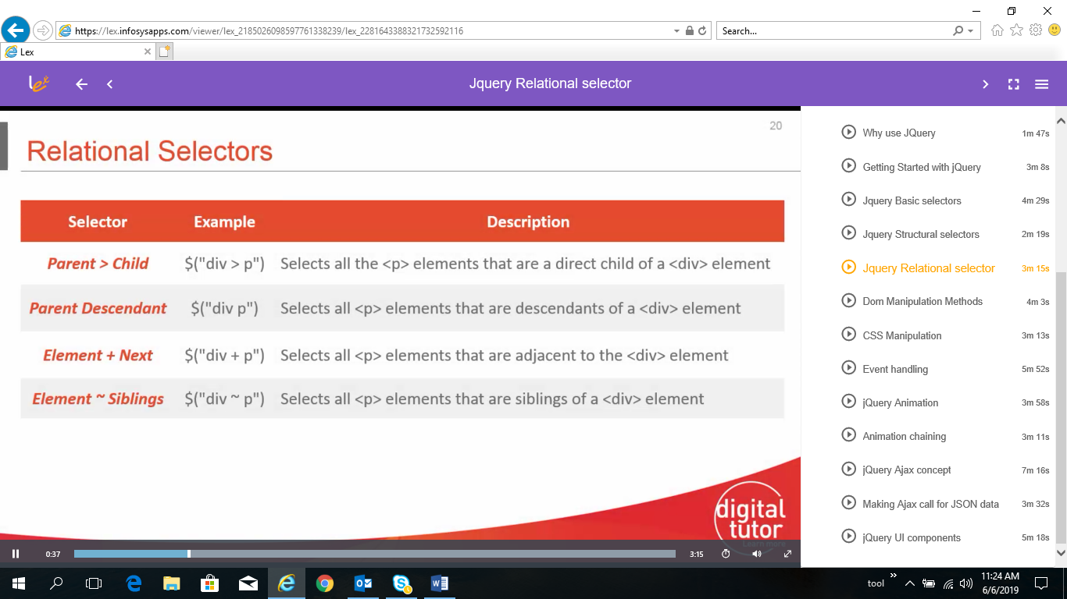

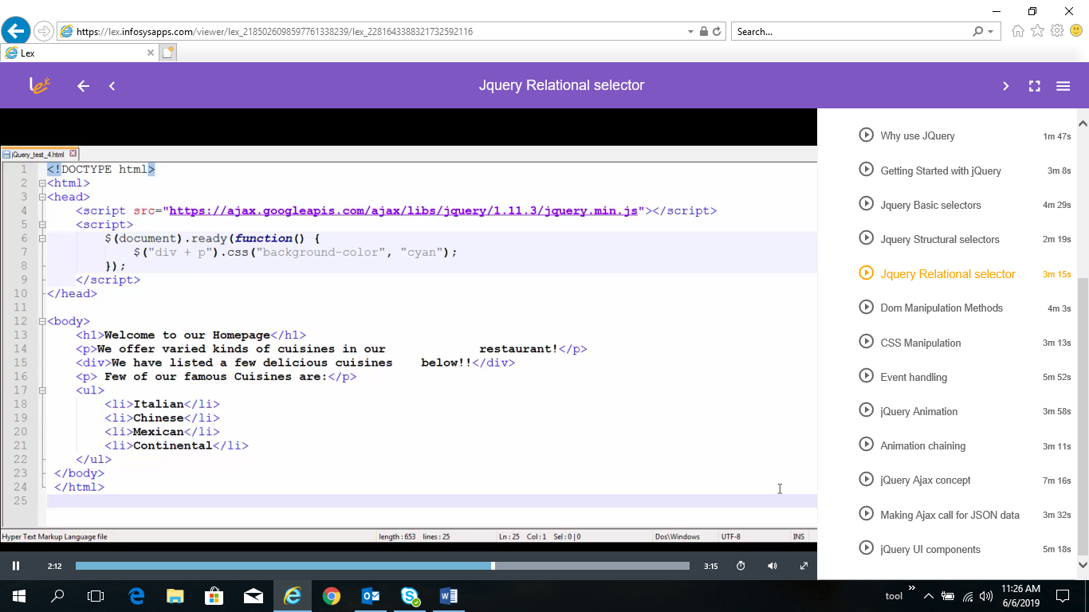

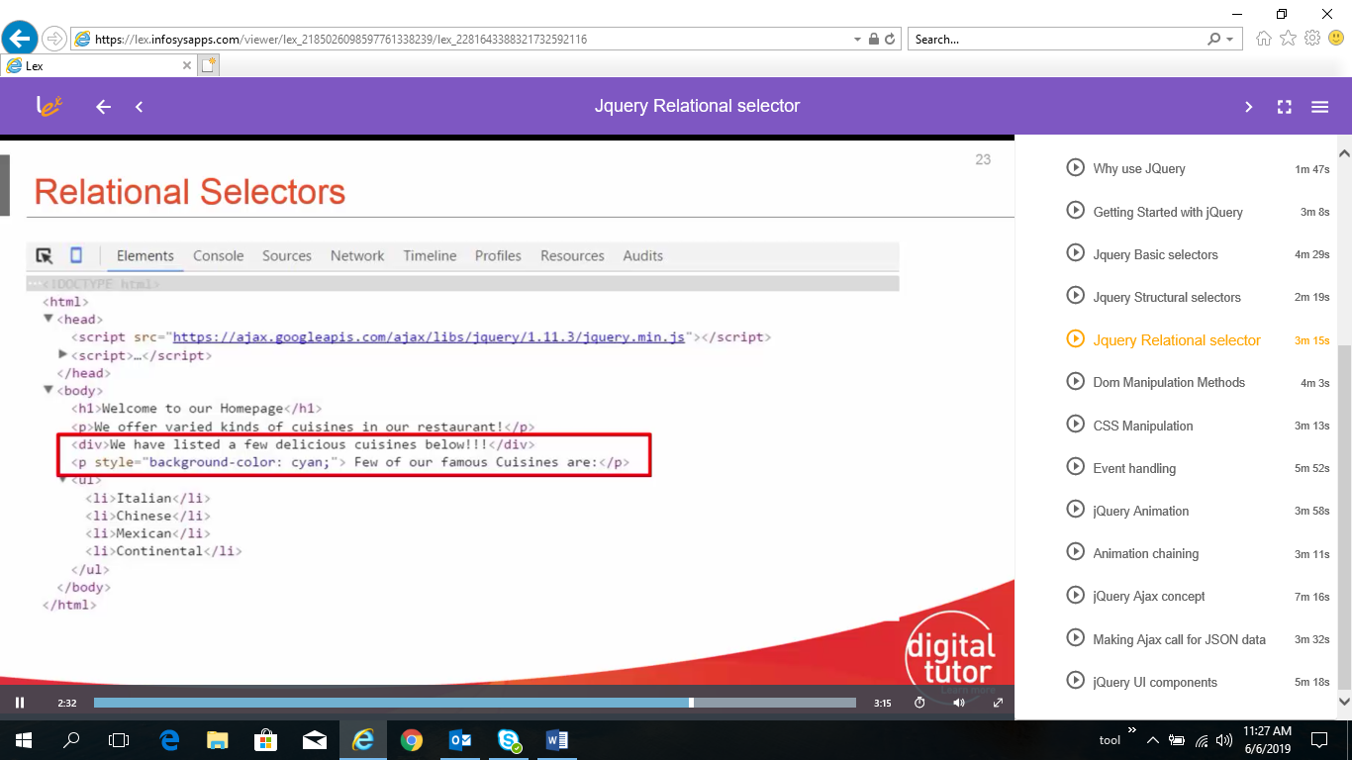

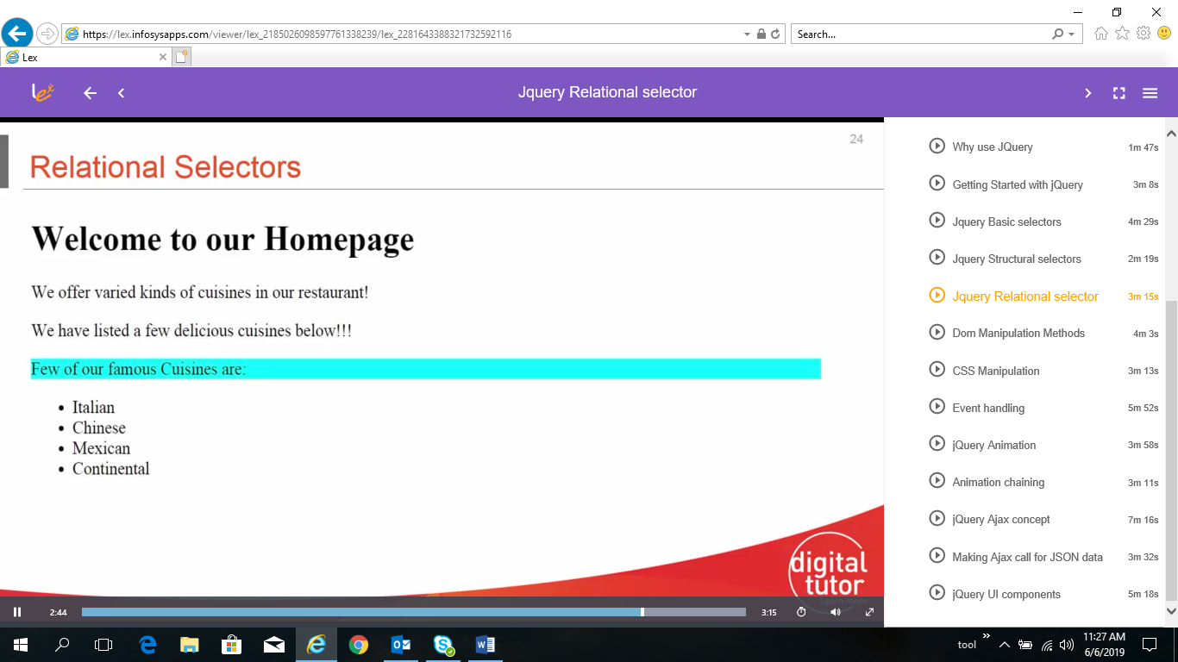

* JQuery DOM method

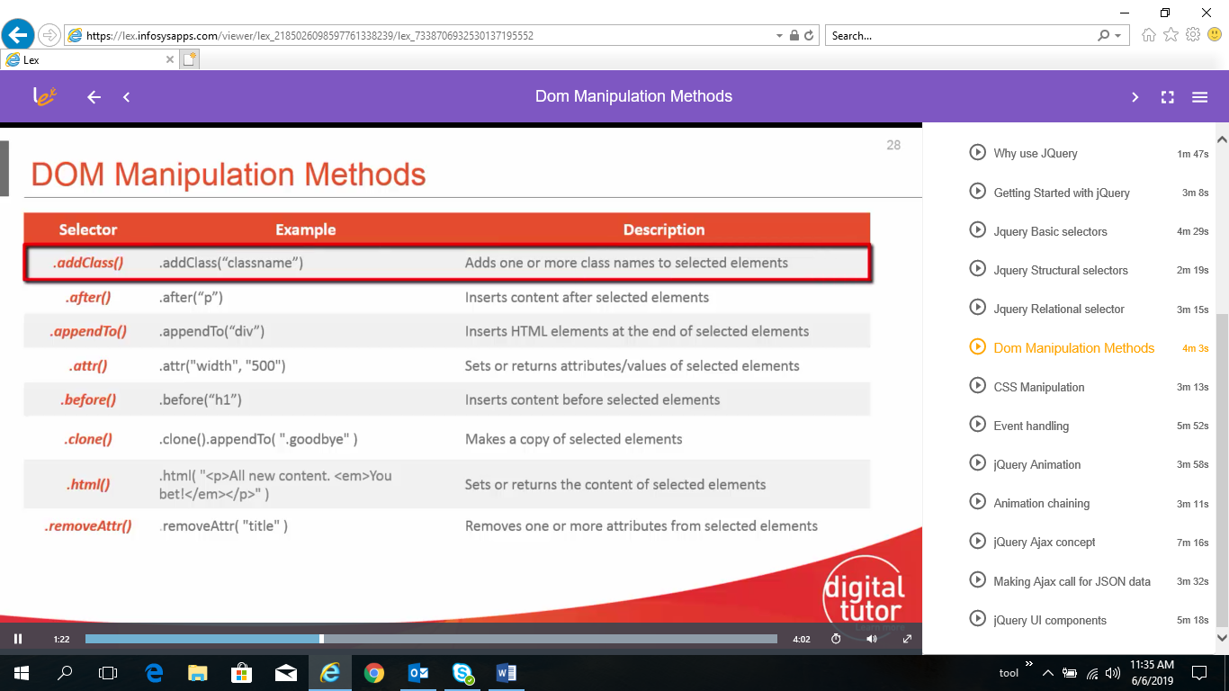

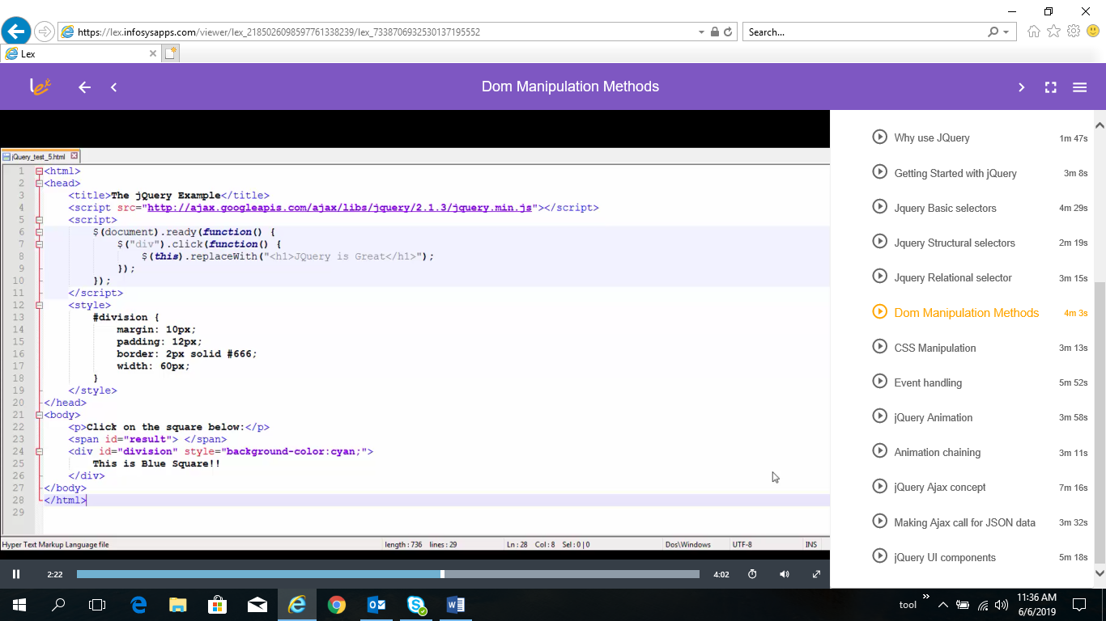

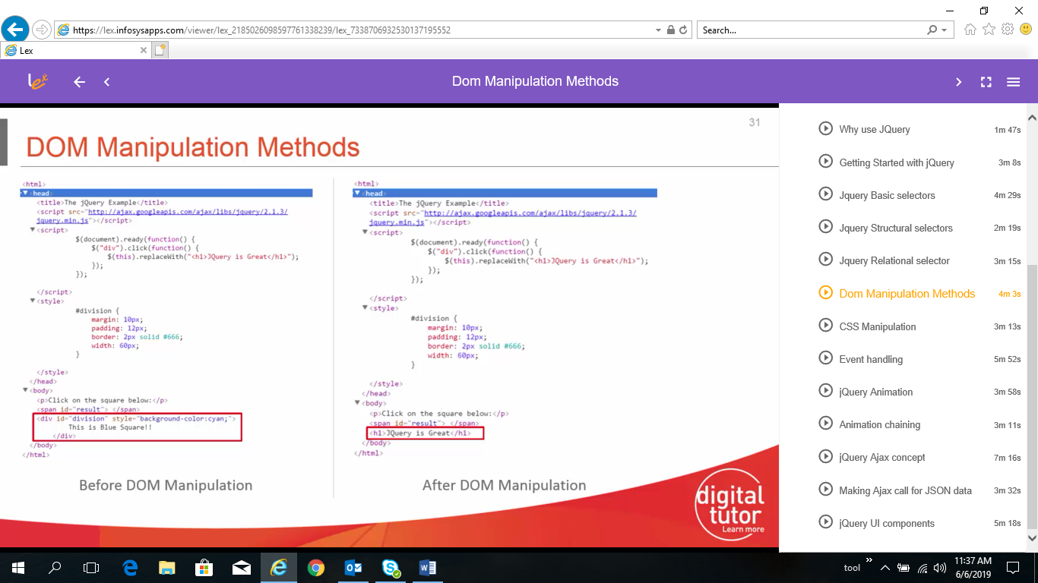

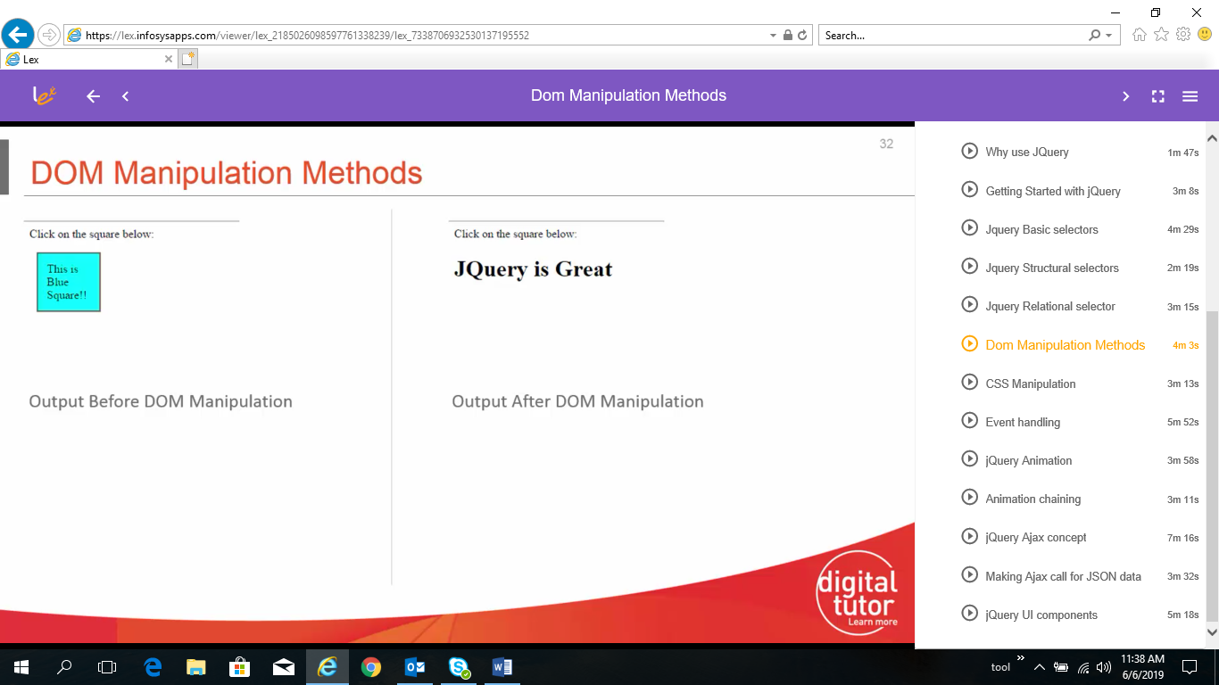

* JQuery CSS method

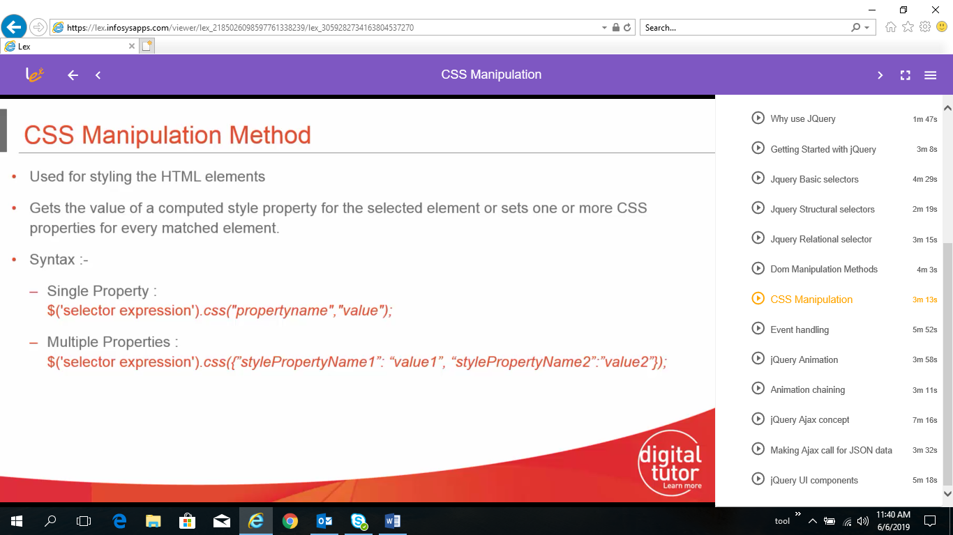

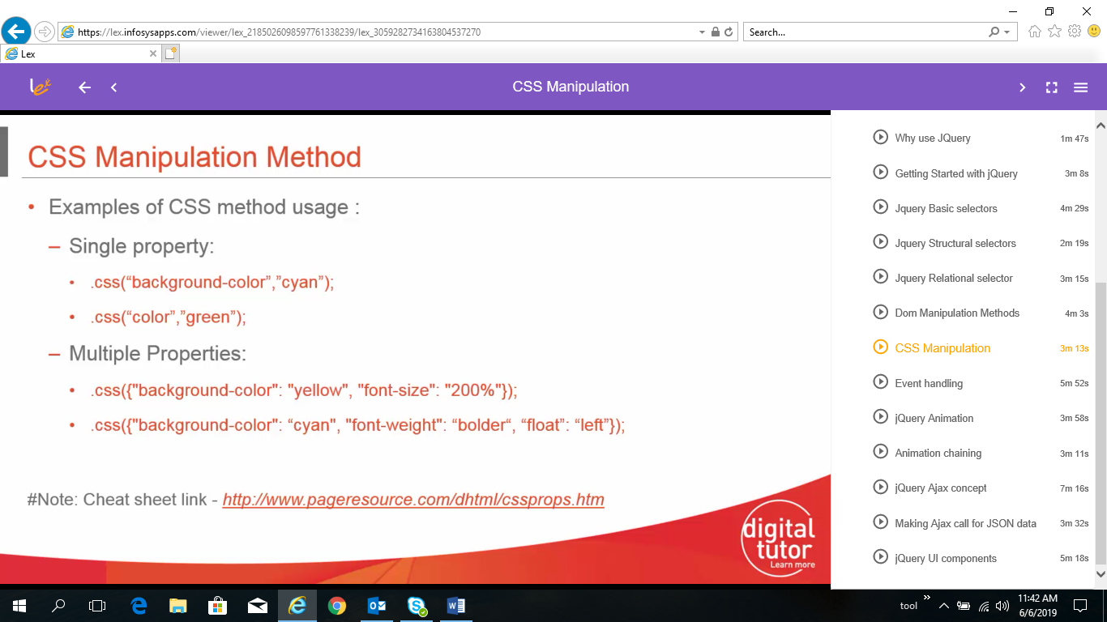

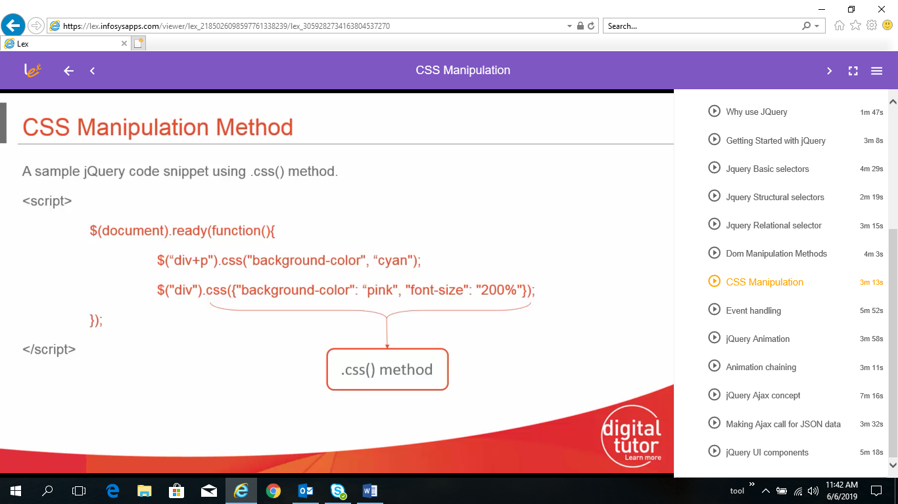

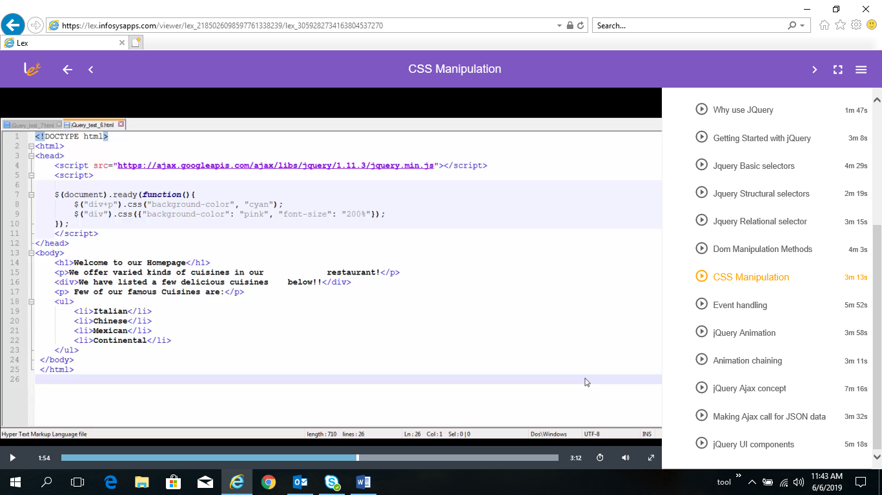

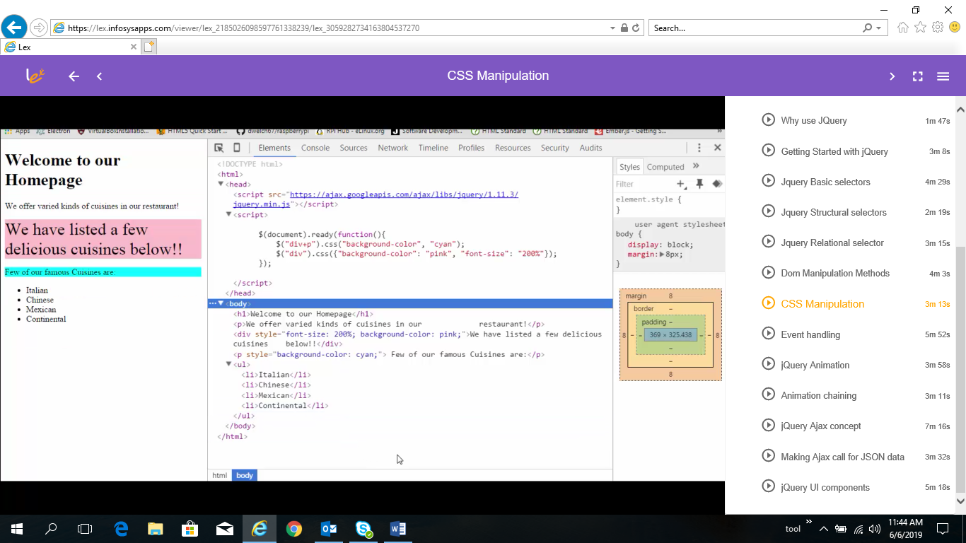

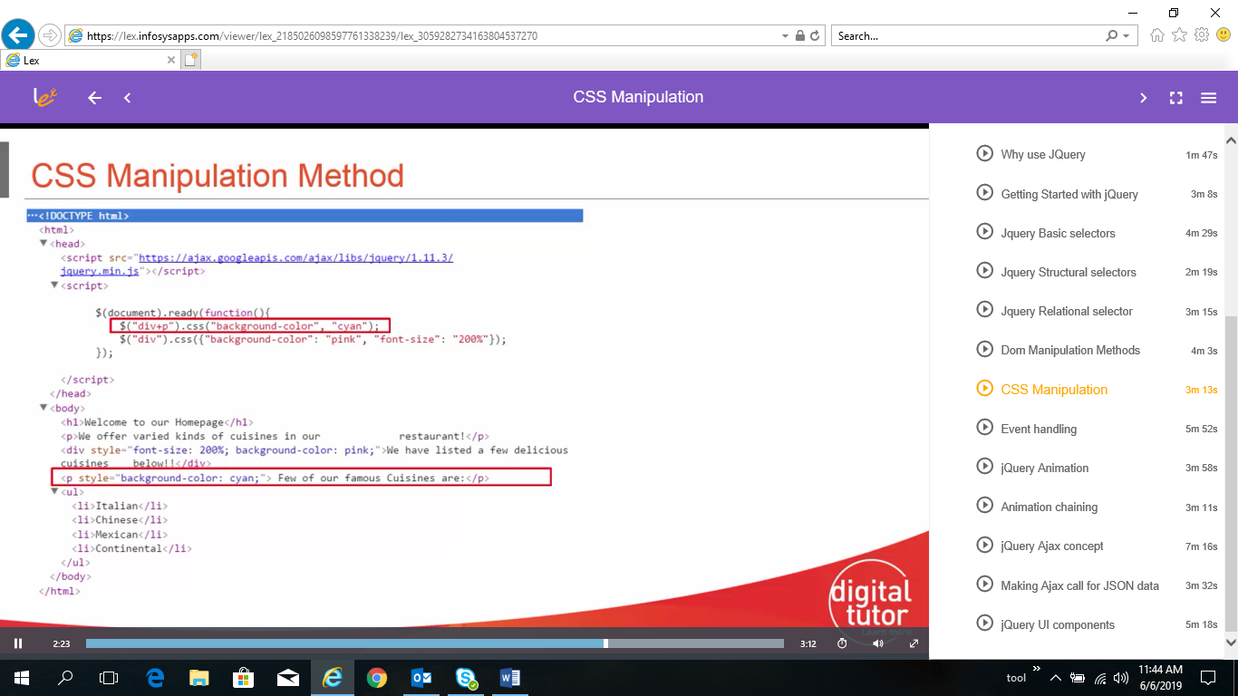

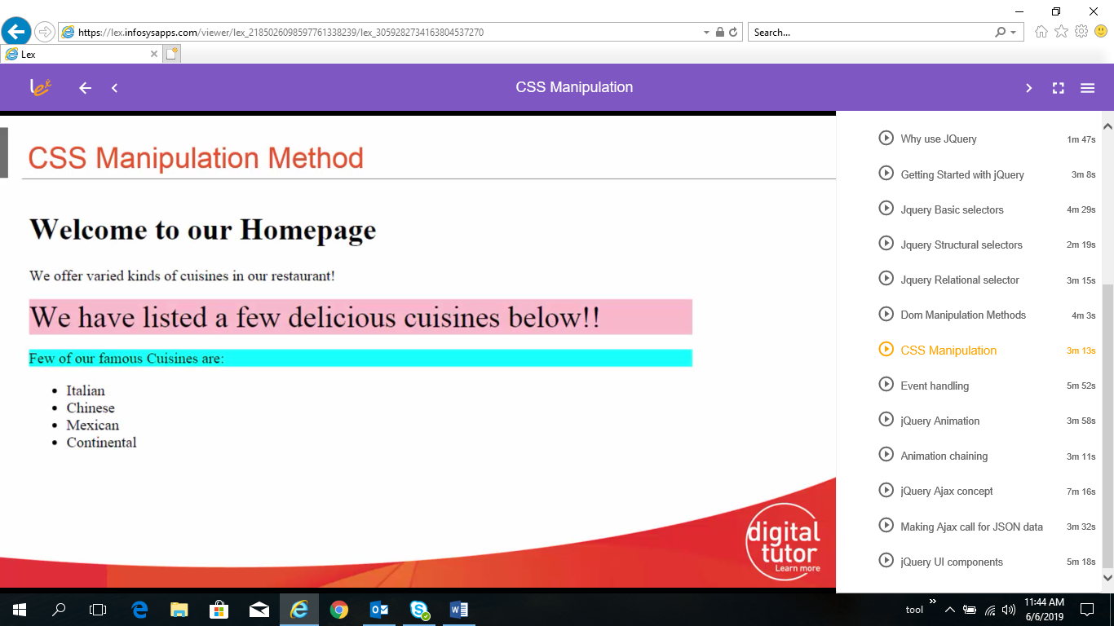

* JQuery Event Handing

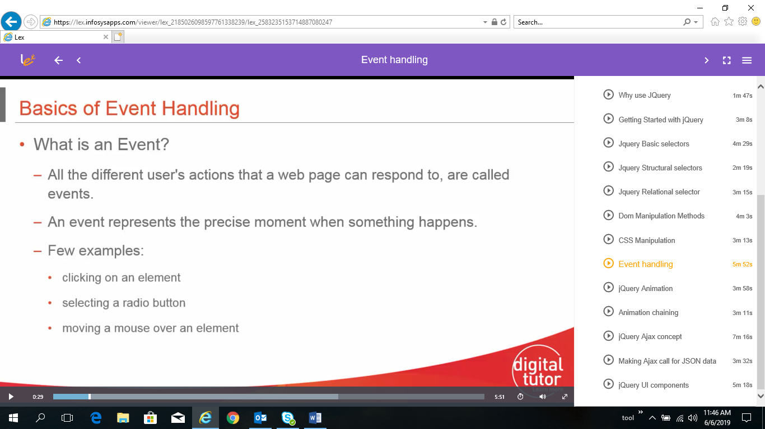

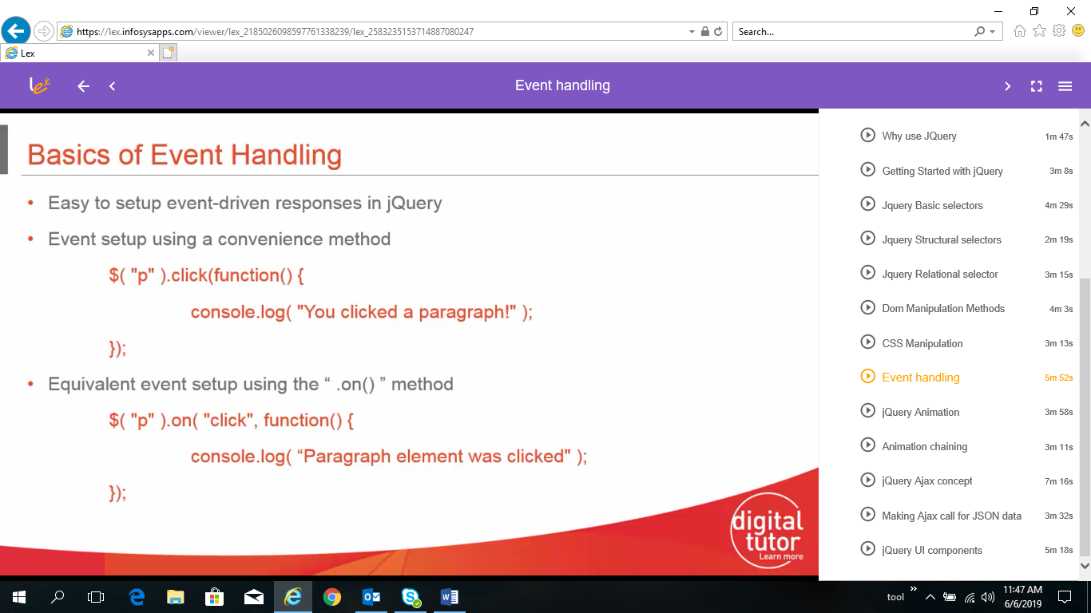

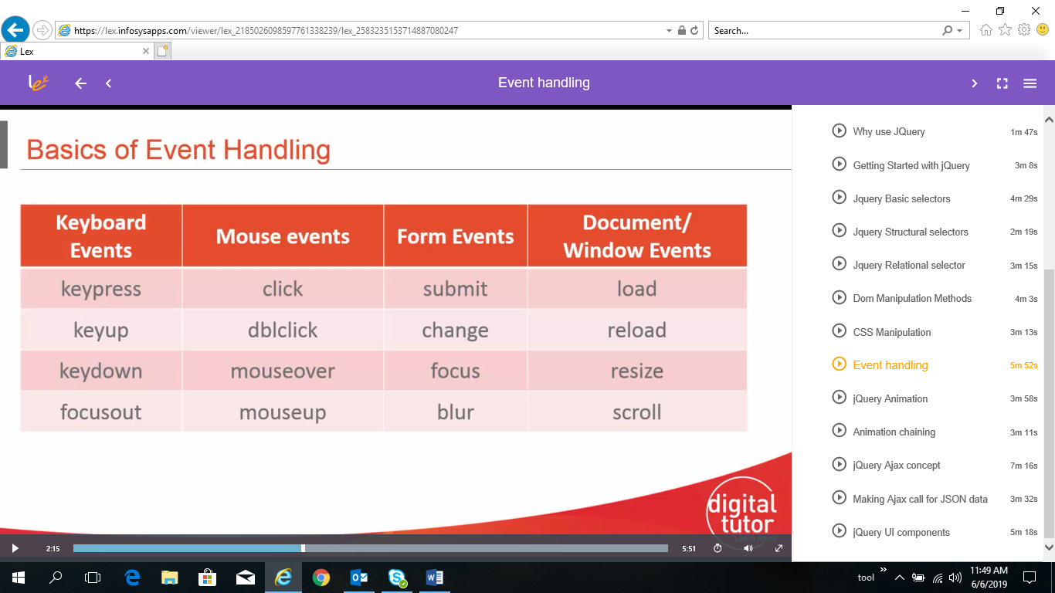

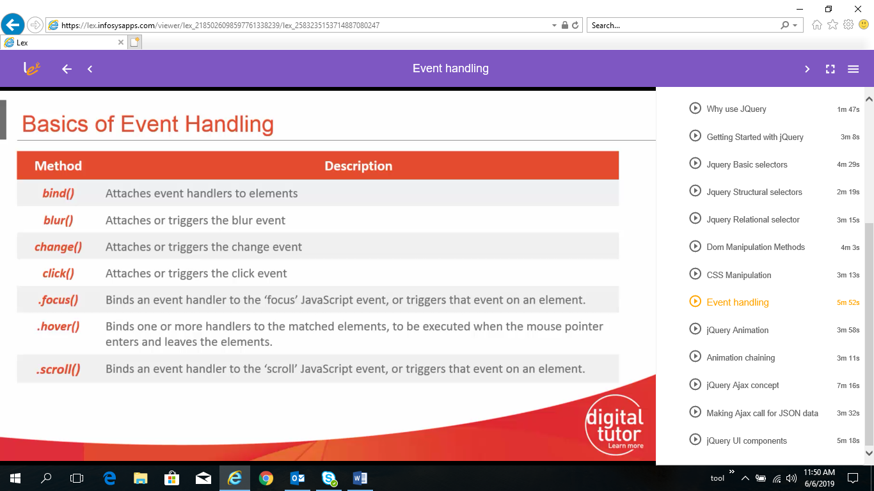

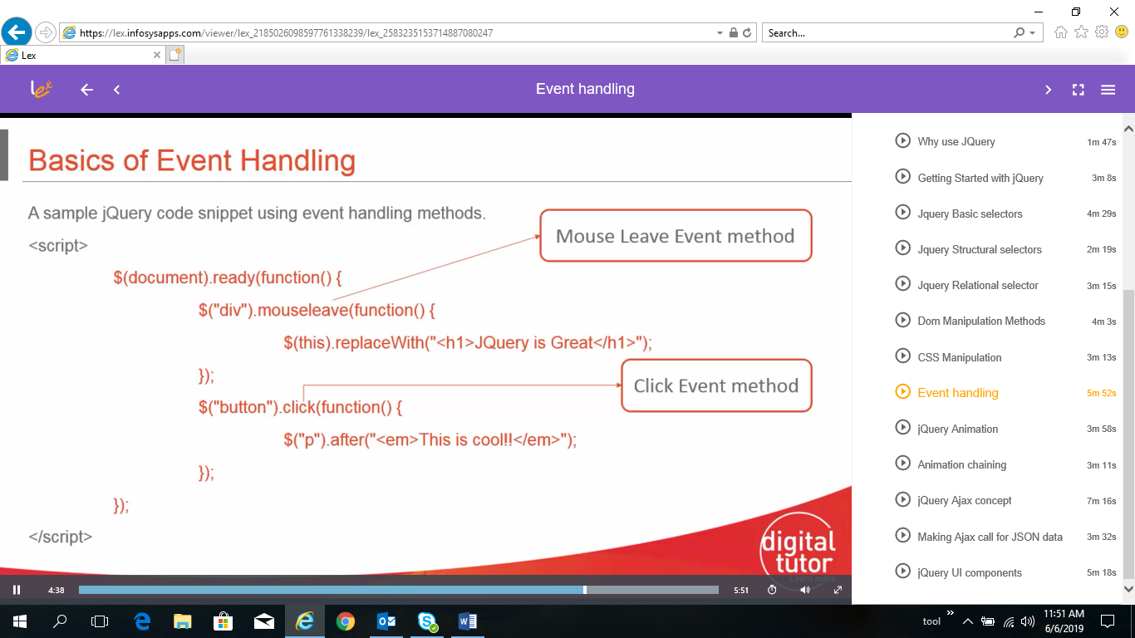

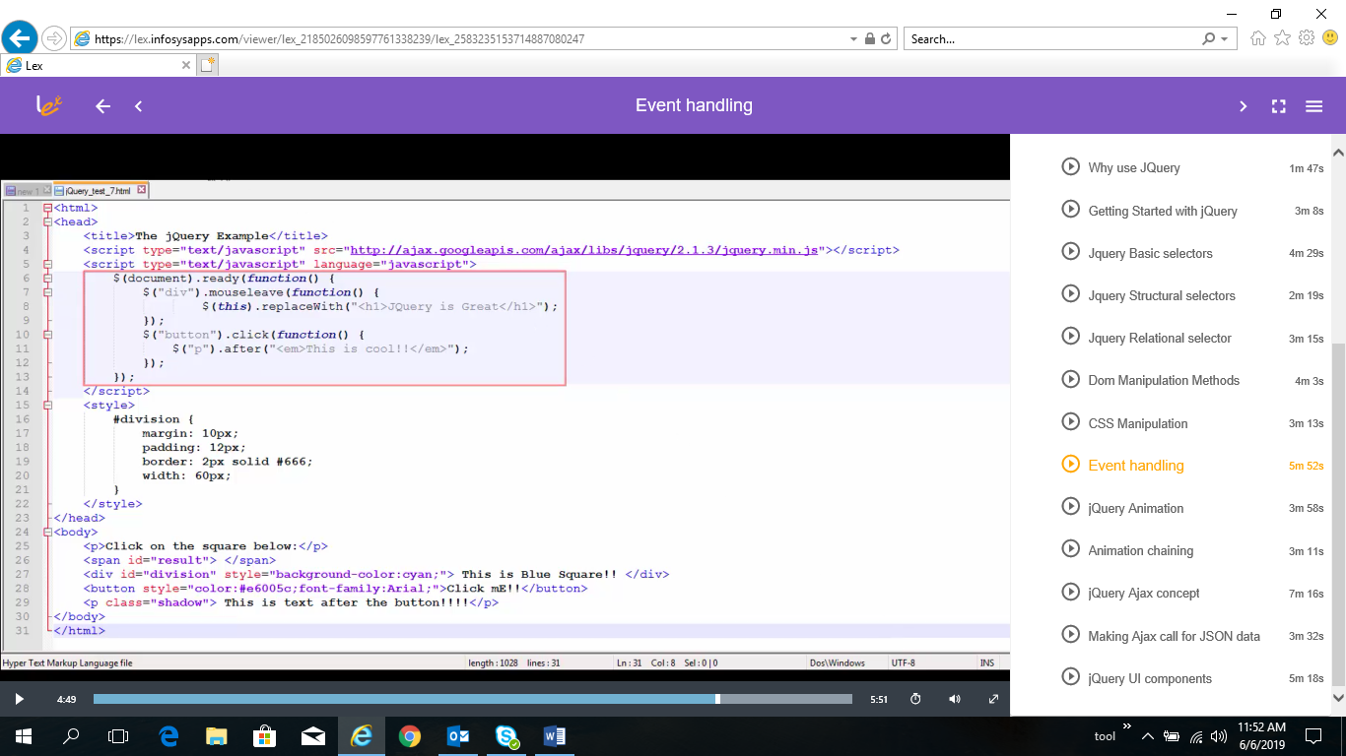

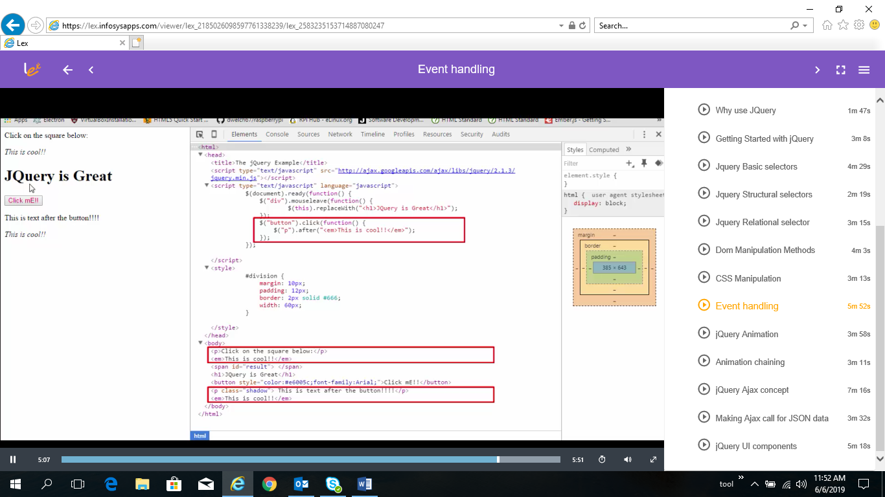

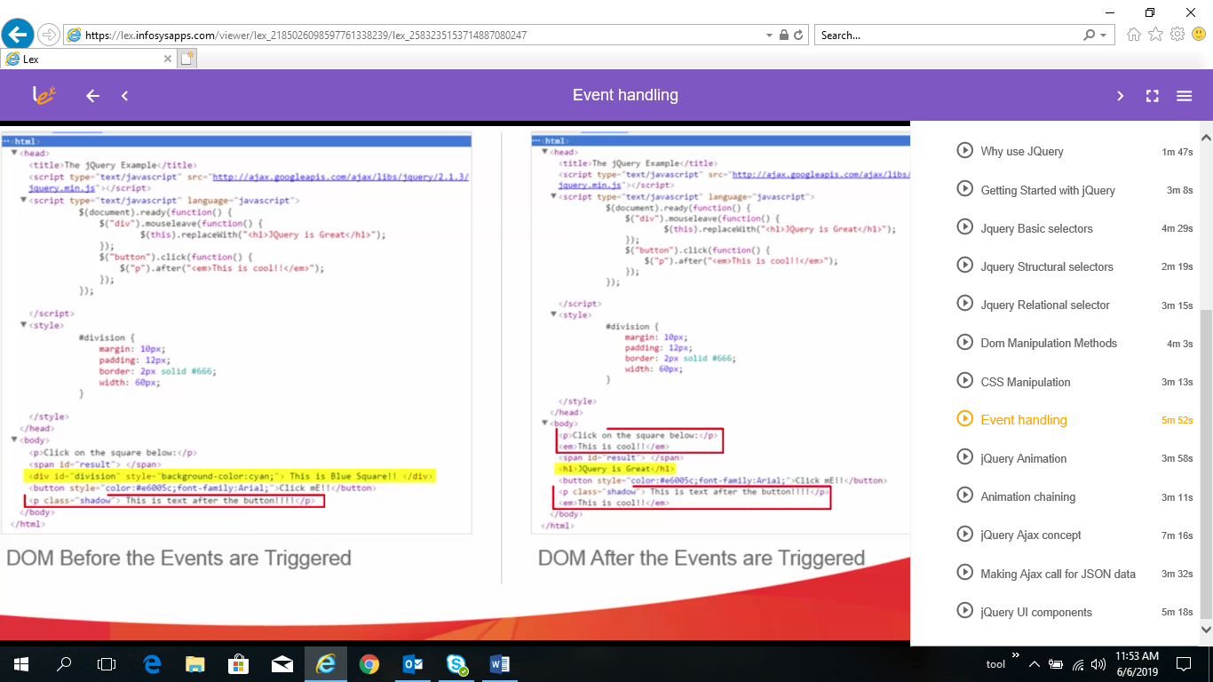

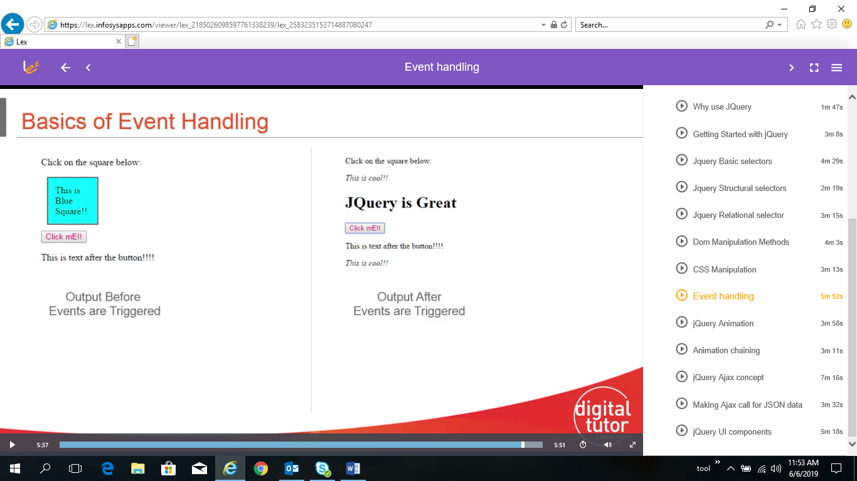

* JQuery Animation

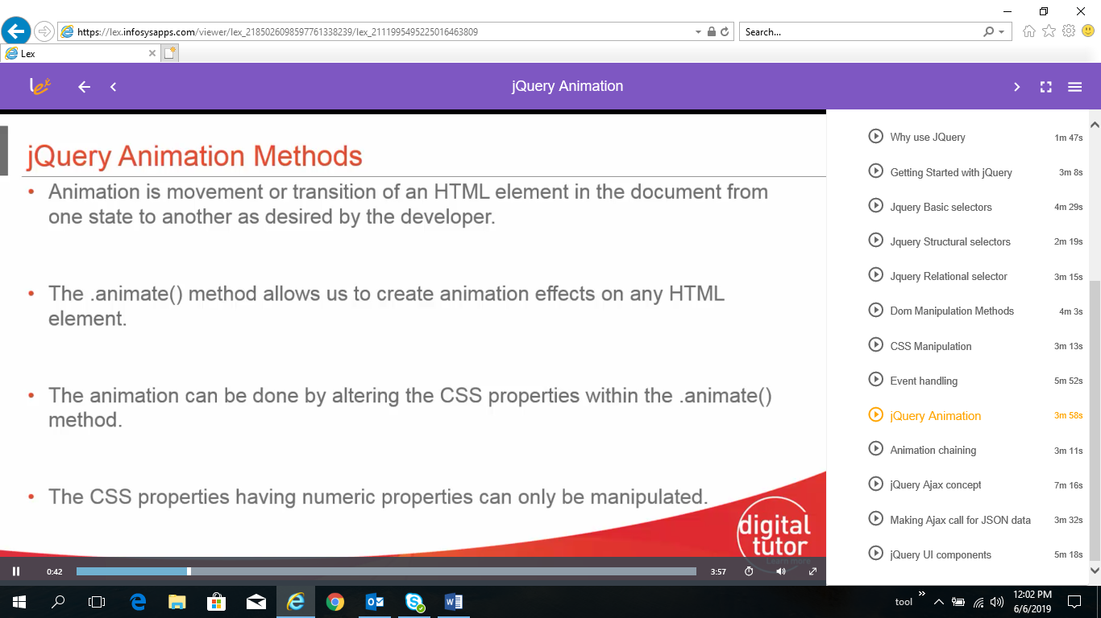

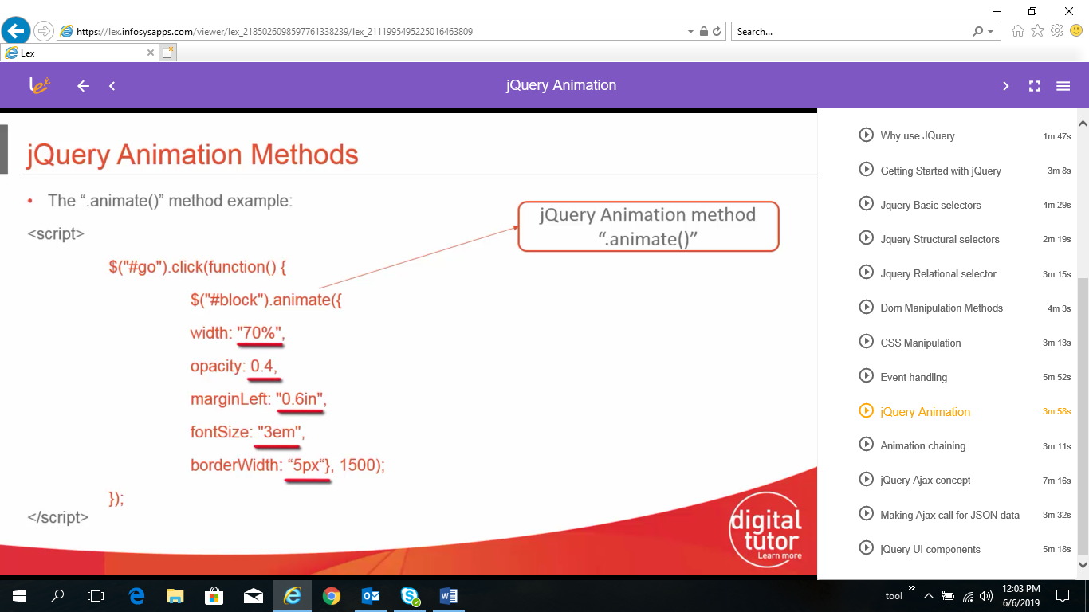

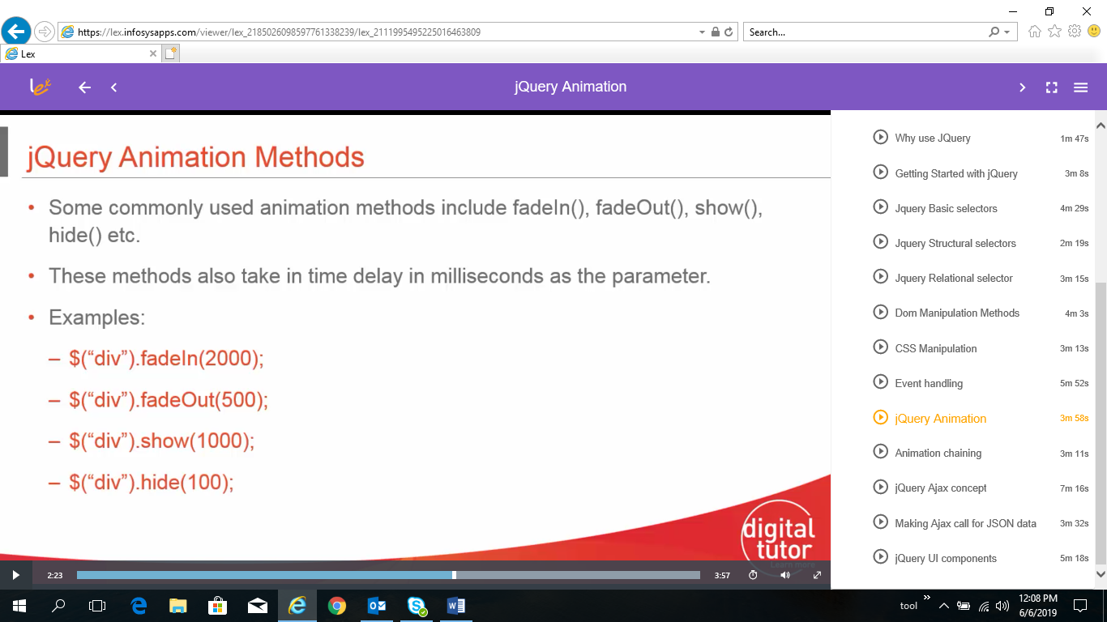

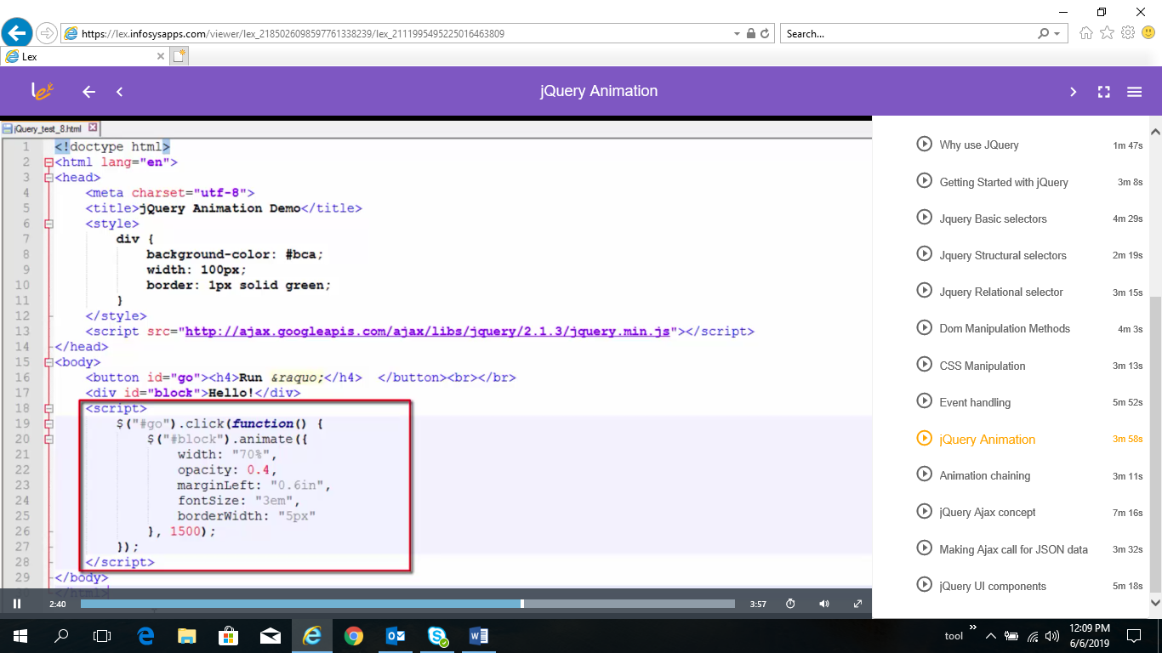

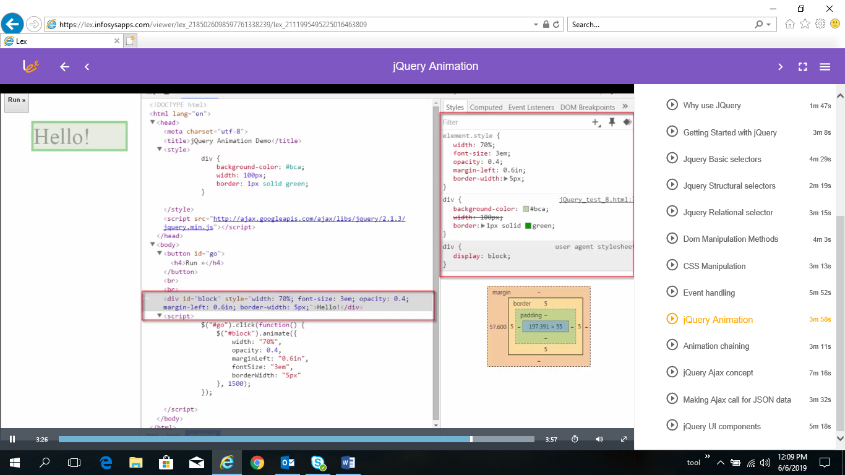

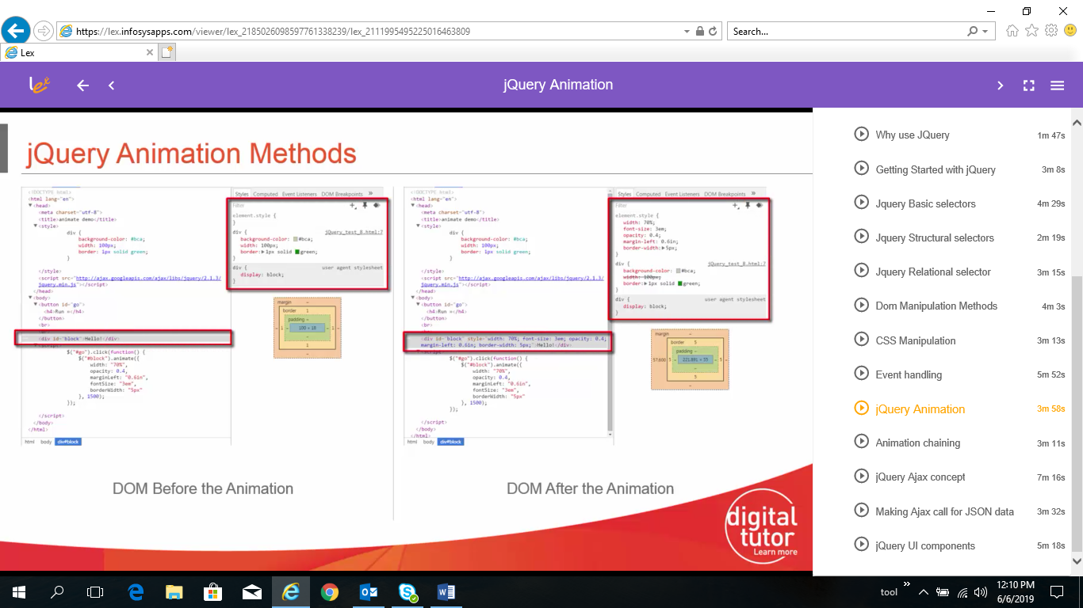

* JQuery Animation Chaining

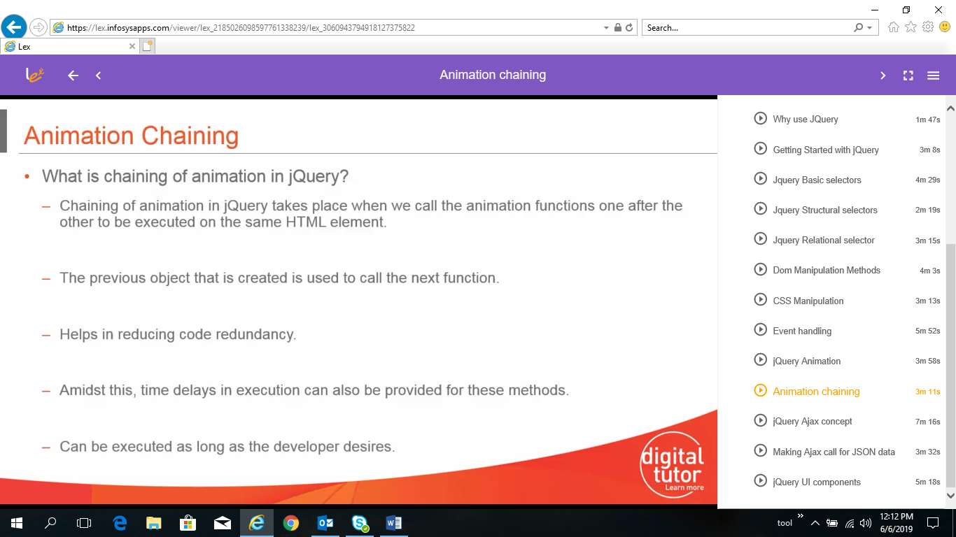

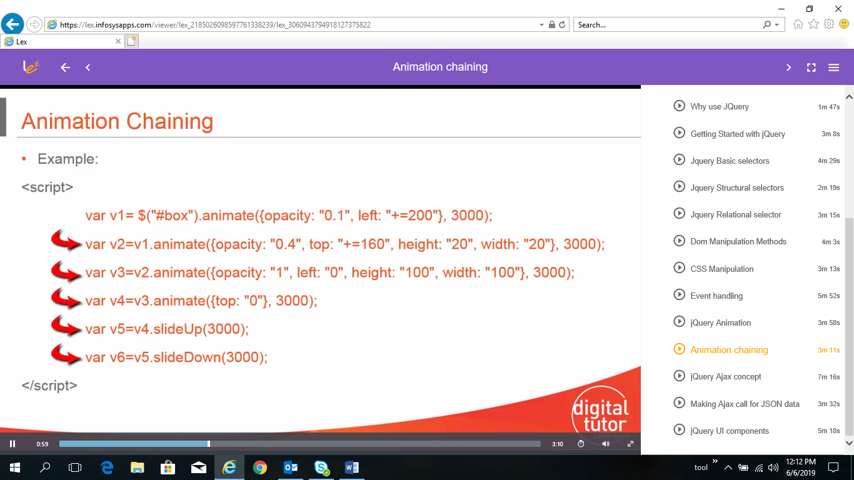

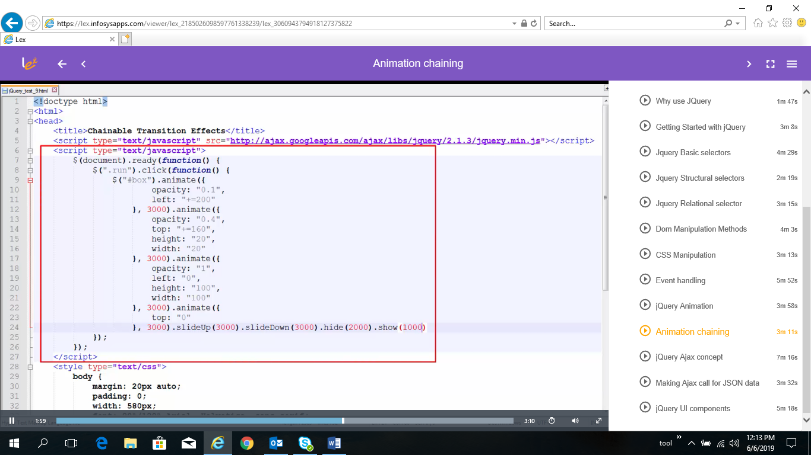

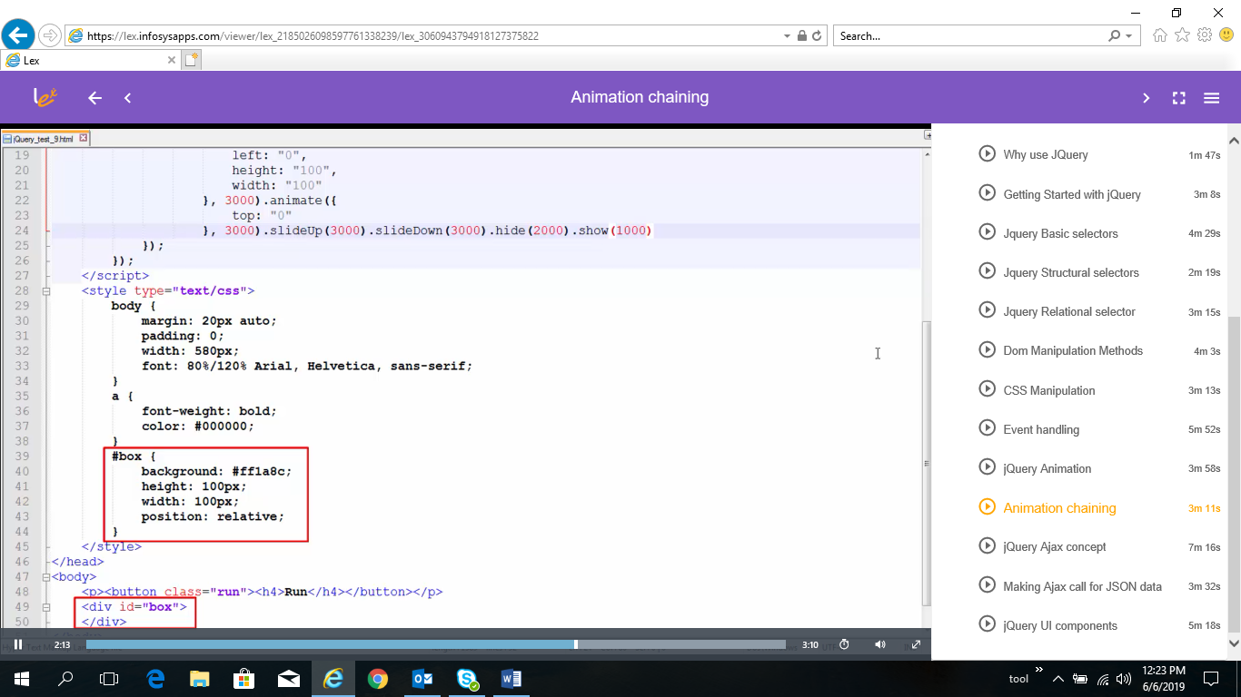

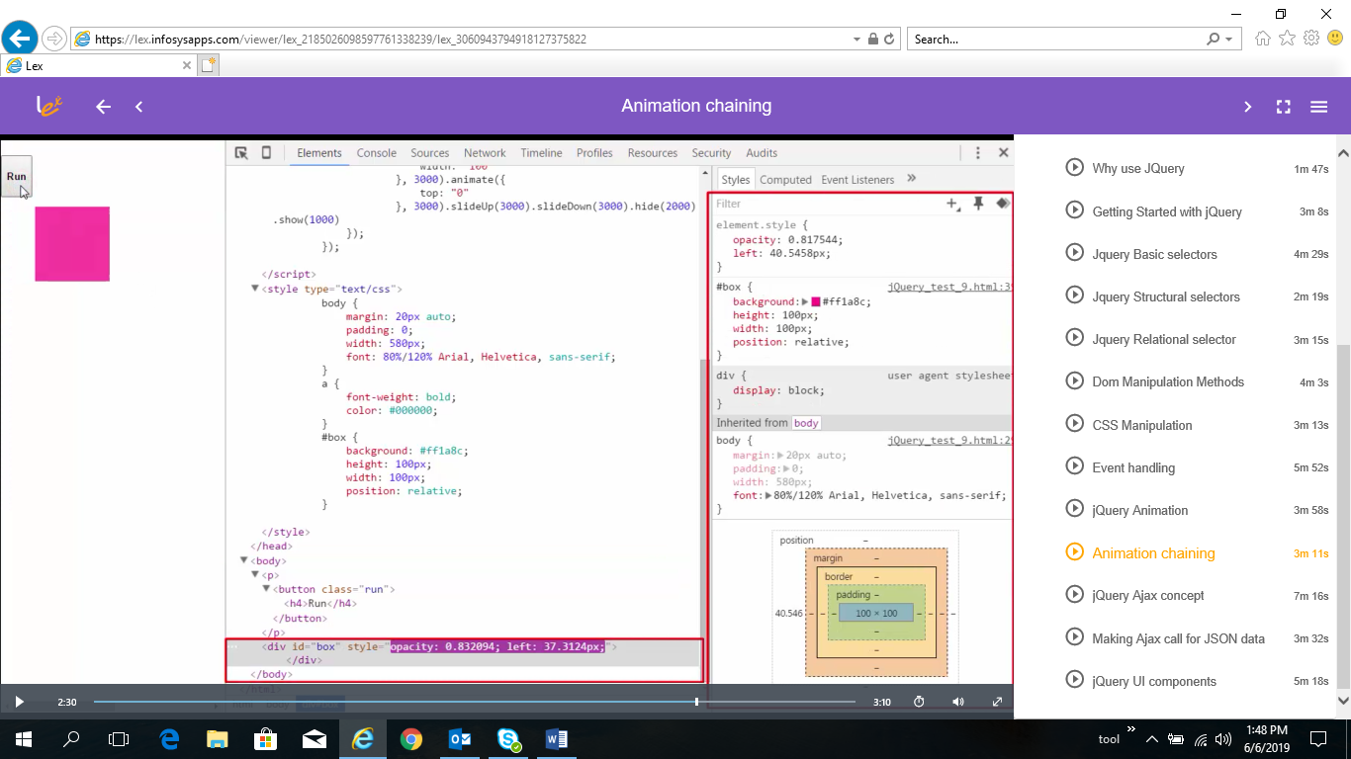

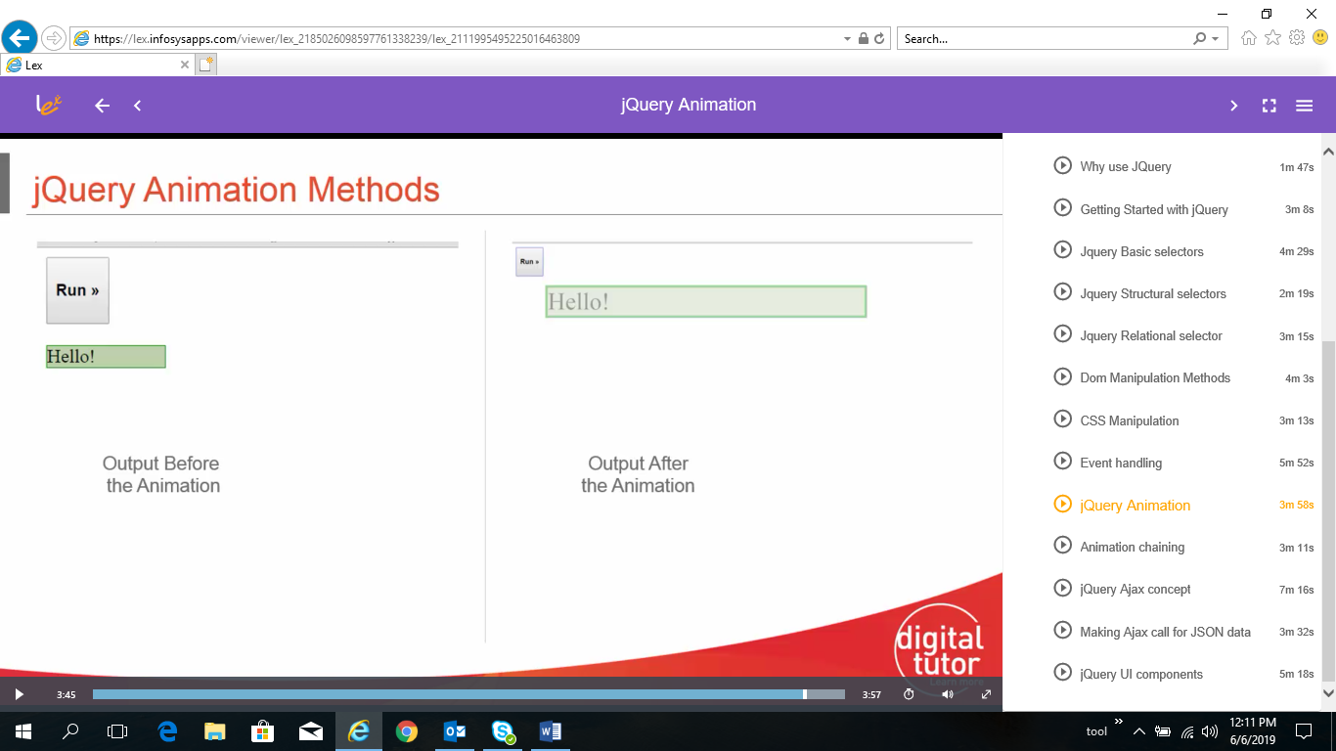

* JQuery Ajax

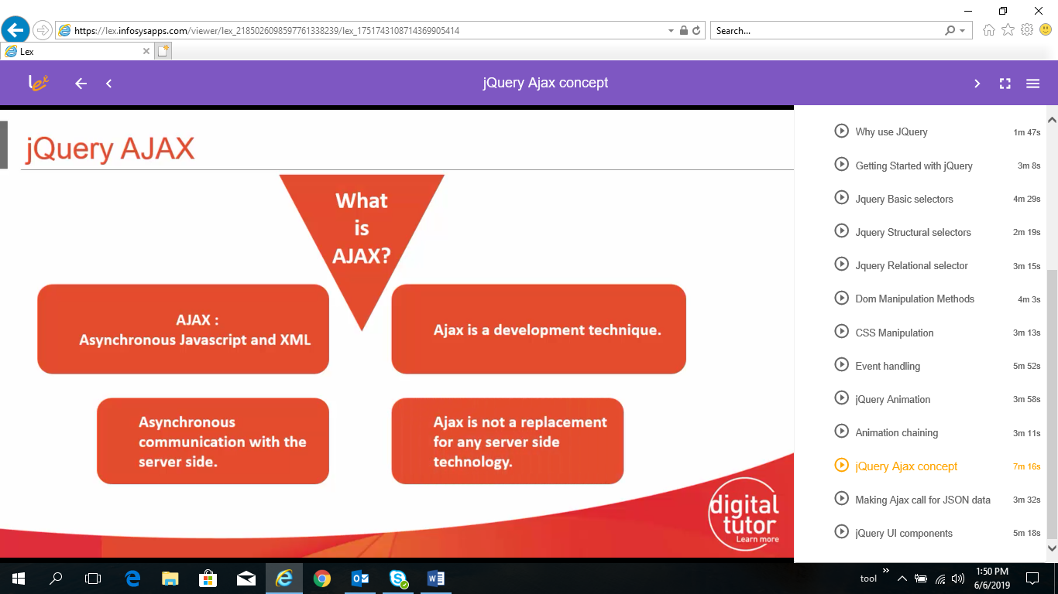

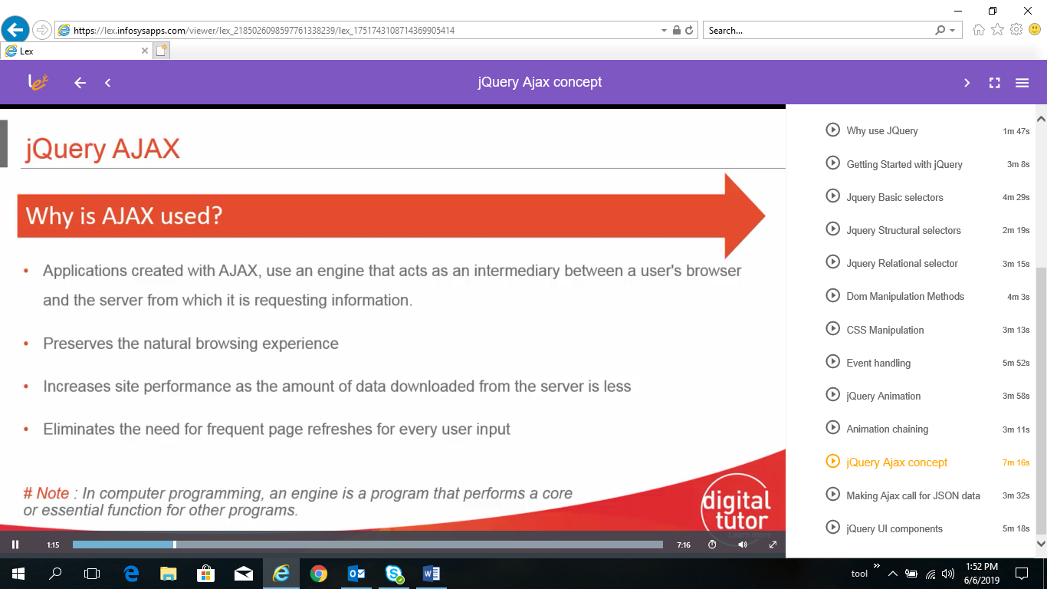

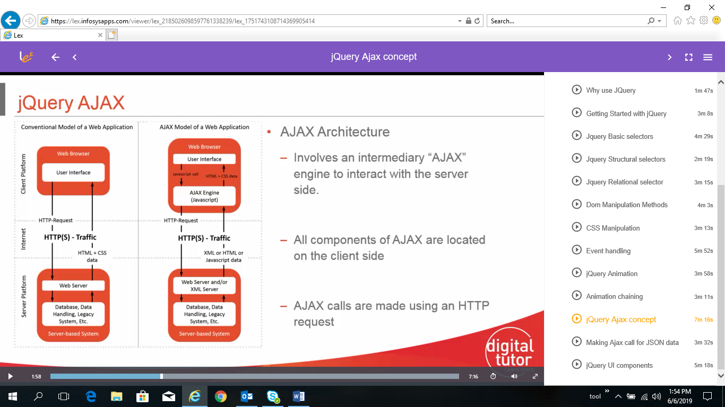

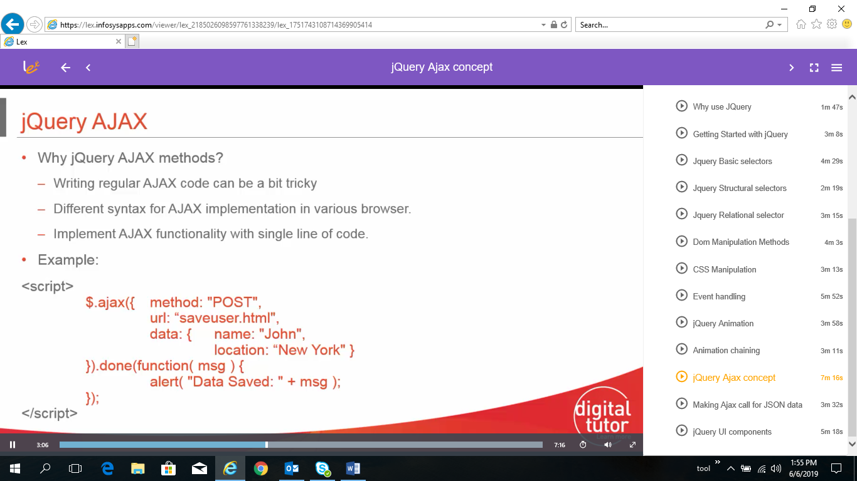

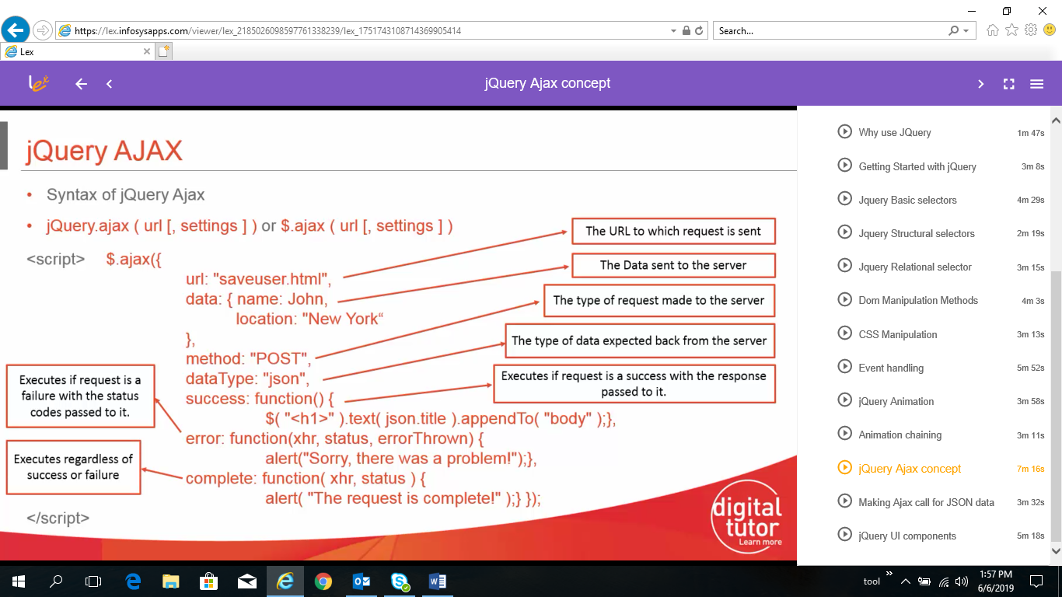

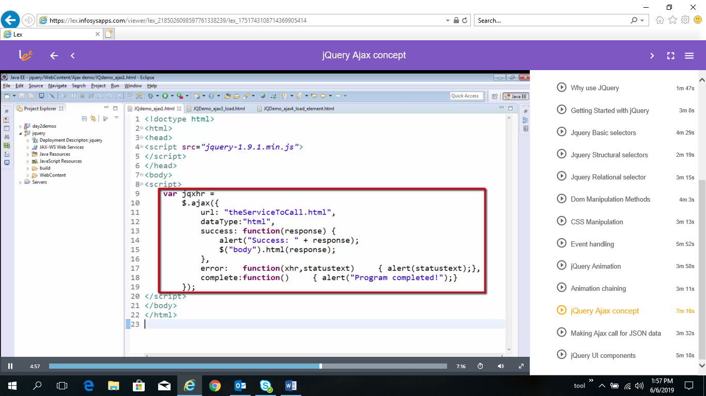

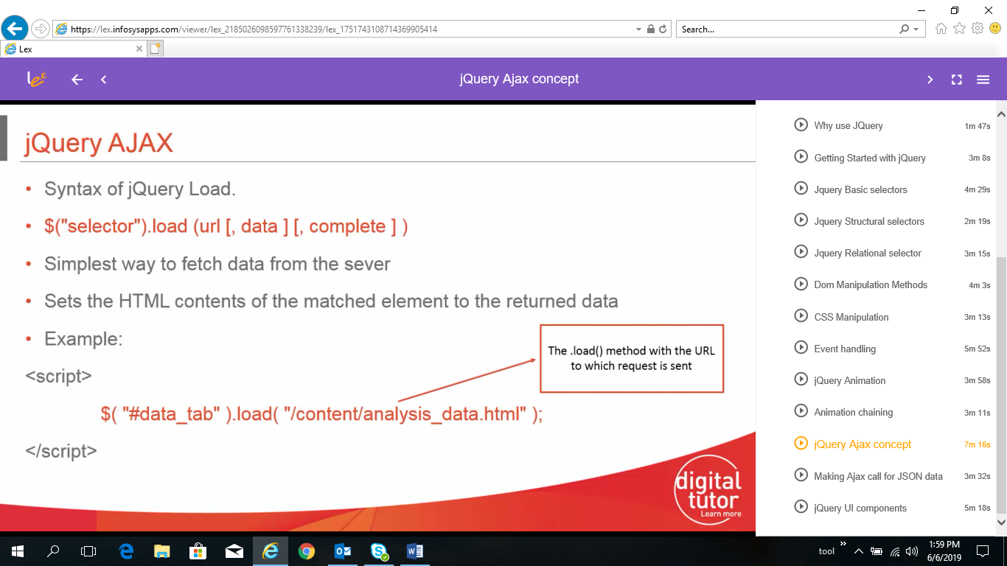

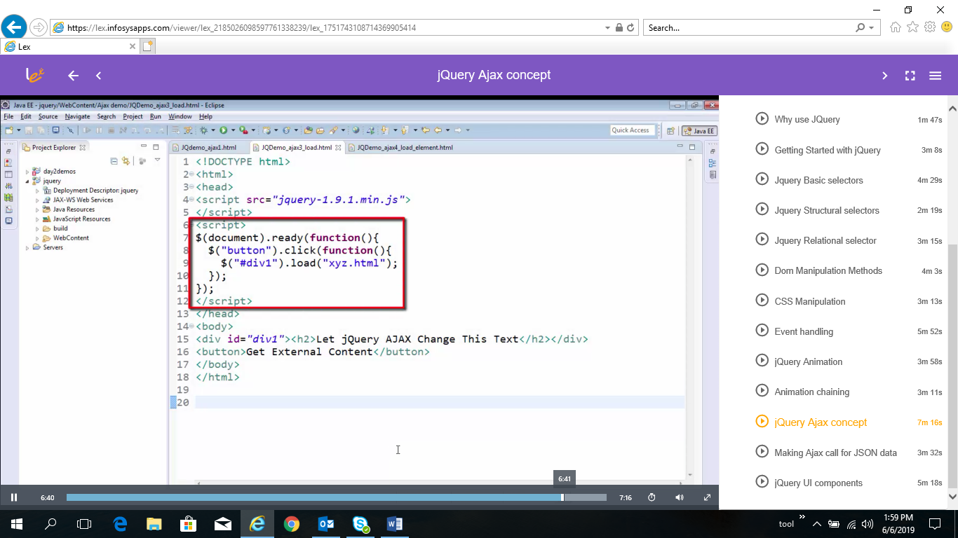

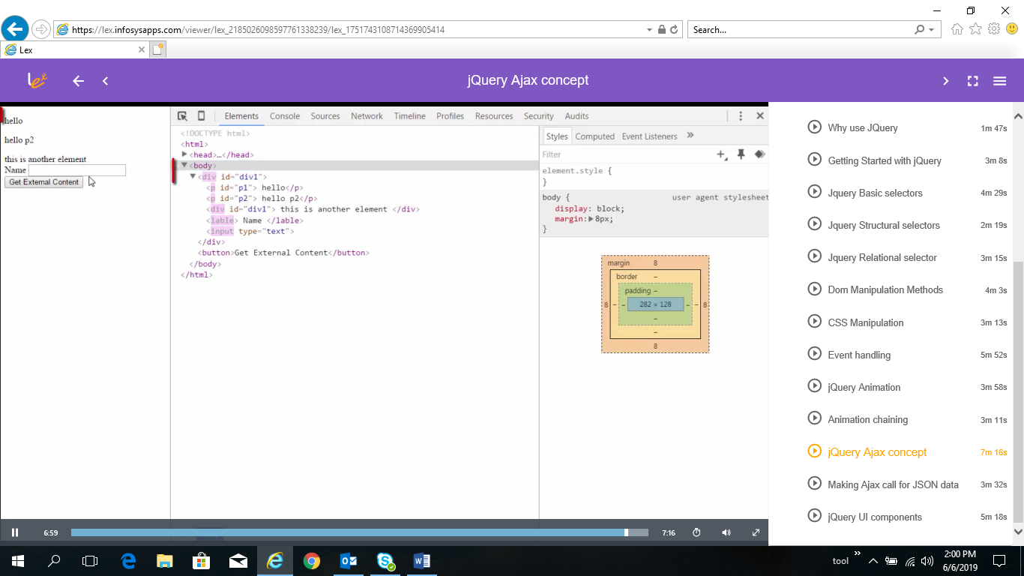

* JQuery Ajax call to JSON

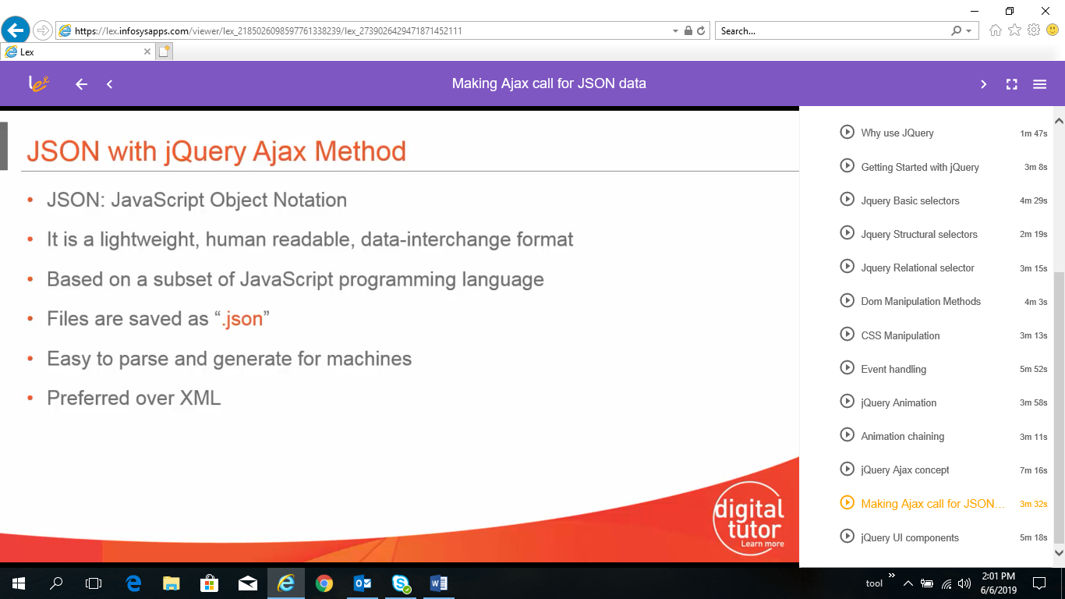

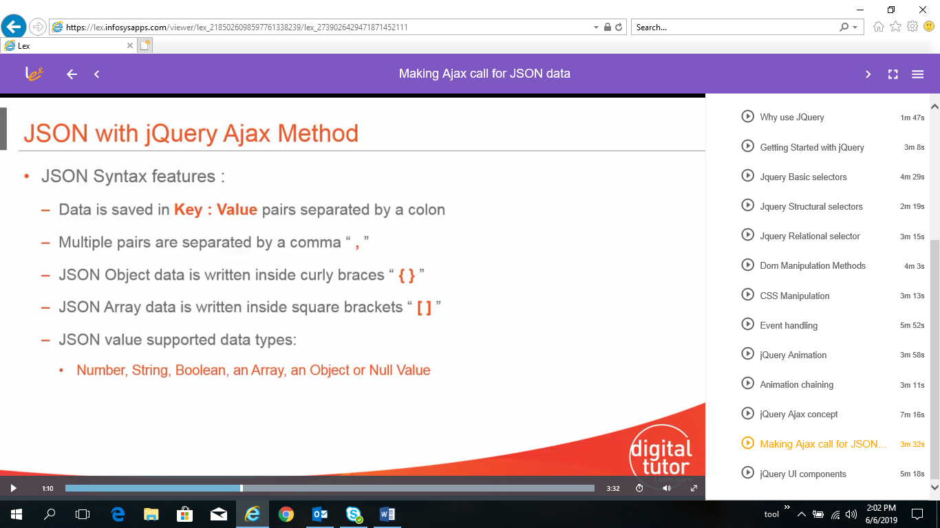

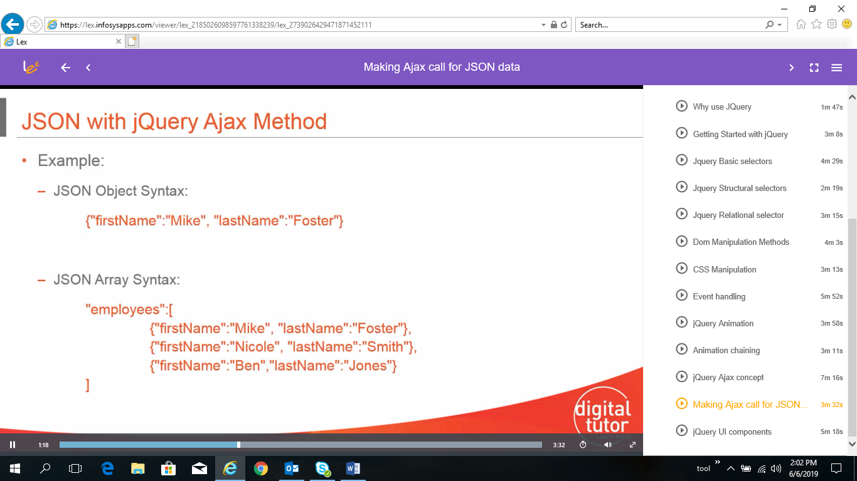

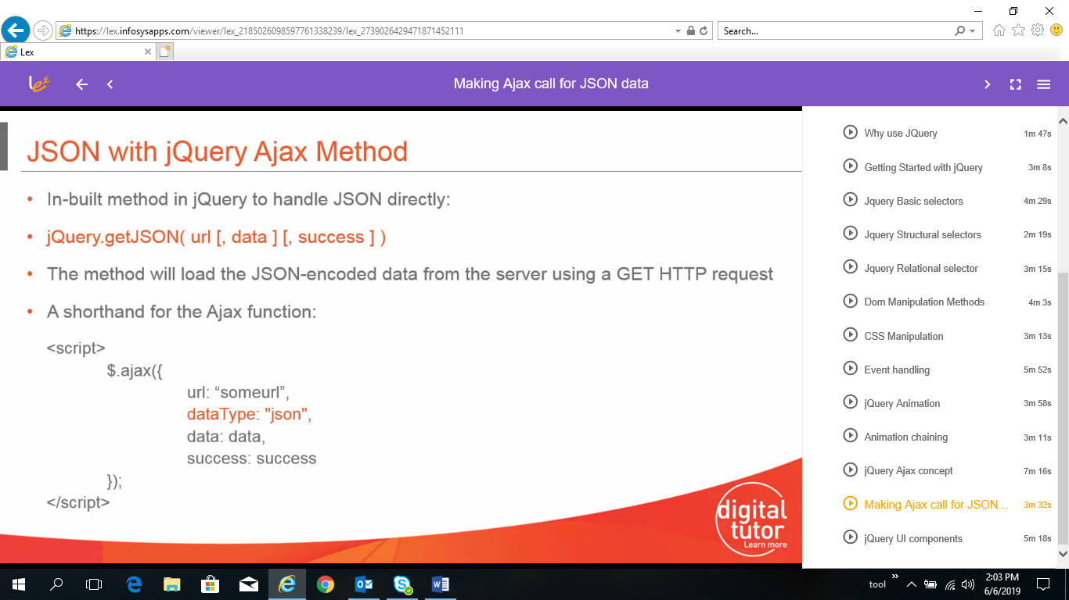

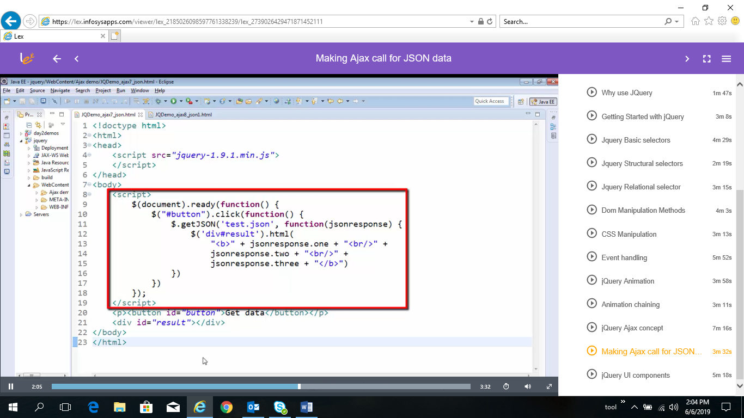

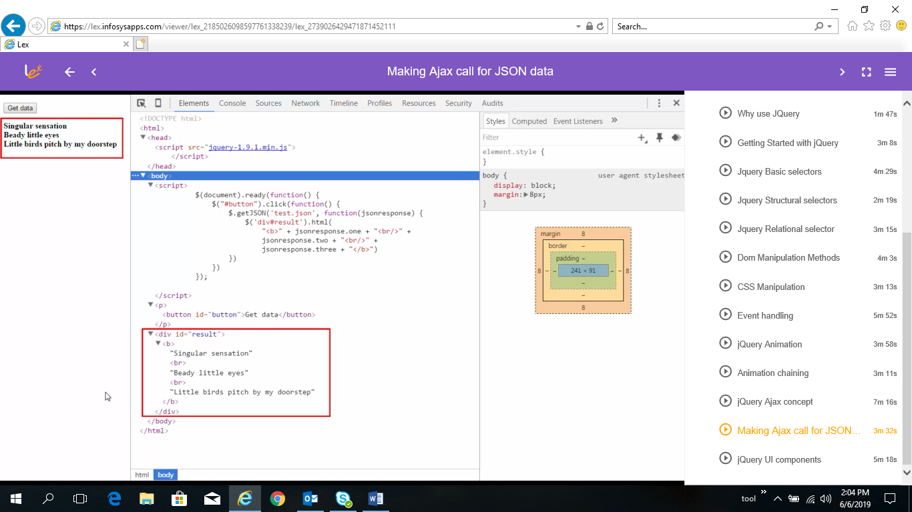

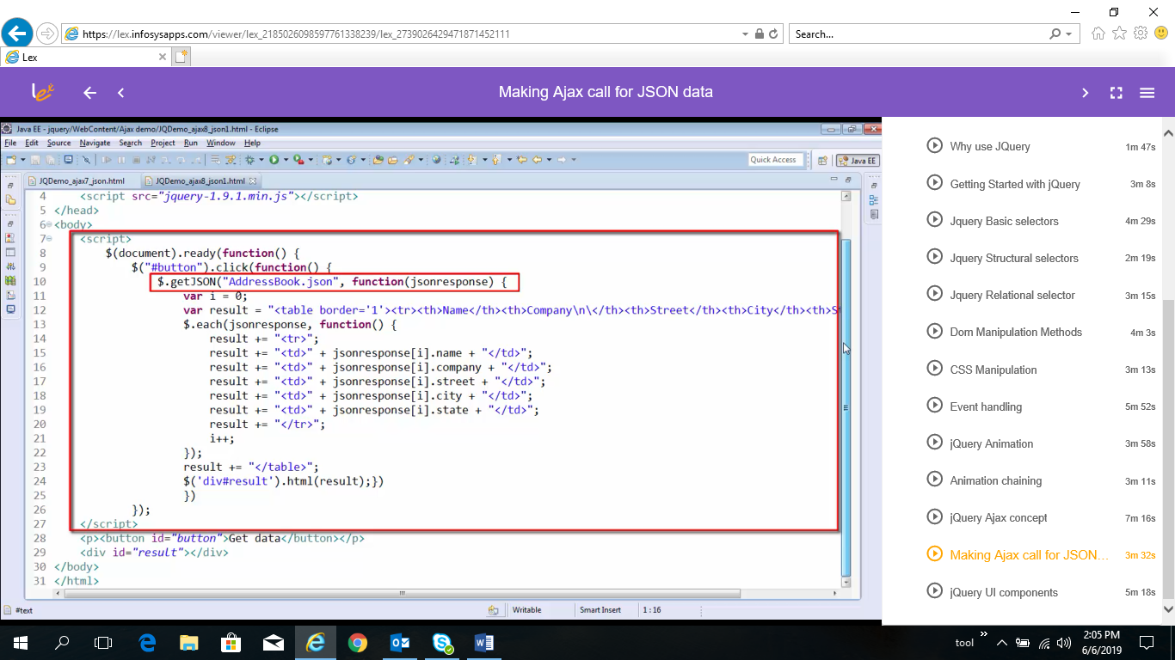

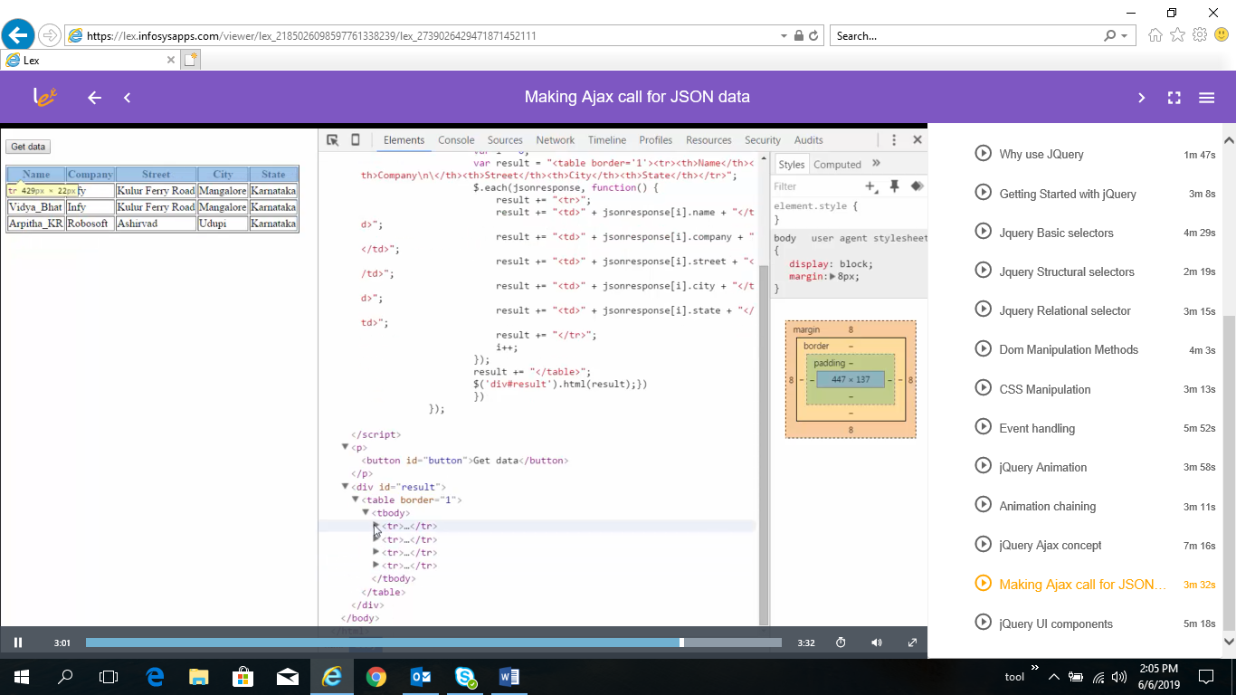

* JQuery UI Component

